

School of Computing and Mathematics

PRCO303

Final Stage Computing Project

FINAL REPORT

BSc (Hons) Software Engineering

J. P. R. Chamuditha Jayaweera

Food Tracker

Supervisor: Mr. Iman Ashley

2020/2021

# Acknowledgement

The author would like to express his gratitude to everyone who has helped with the project. Specially Mr. Iman Ashly, Course Director Dr. Rasika Hewawasam Ranaweerage and all the other Lecturers who provides continual assistance and direction to the author during this endeavour. With

their complete assistance, the author was able to successfully complete the entire project. The

counsel and manner in which they assisted with the challenges encountered were very appreciated.

The library and the internet were particularly useful for references. Finally, the author accepts full responsibility for any flaws in this dissertation and declares that it was a real labour of hard

work.

# Abstract

Food tracker is an application solution for the customers as well as the shop owners. This solution can be used as a food tracker and inventory management system for the customers and for the shop owners respectively. Food tracker inventory management system can be used for the sellers to track their food items without wasting. And other hand shop owners can retrieve the clear details about their inventory.

From the details sellers or the shop management could make decisions about ordering more food items to shop or what are the food items that have lower sales amount and get better idea and execute decision to get proper benefits. For the shop owners or the sellers also getting a mobile application. That can used to insert their products details or their product’s batch details. That mobile application having Optical Character Recognition technique to add items to list by scanning them. From that technique those sellers could save their time and effort using this simply mobile application. Food tracker application is way more low-cost solution other than using the tech devices that created only for only purpose. And this application is valuable to the domestic customers or the users. Because they also facing the same problem as the shop owners or the sellers. As a conclusion this solution is simple and highly productive to the people to all around the world. They can get informed, notify when their foods are about to expire. So by that users can get any necessary actions before it getting expired.

Keywords: Food Tracker, Management, Tracker, Mobile, Inventory Management, Web Application

Table of Contents

Acknowledgement 2

Abstract 3

1. Introduction 8

2. Background 9

3. Objectives 10

4. Deliverables 11

4.1 Food Tracker mobile application for the domestic purposes: 11

4.1.1 Splash screen/ Loading screen 11

4.1.2 Login 12

4.1.3 Sign up 12

4.1.4 Forget password 14

4.1.5 Main menu 14

4.1.6 Side panel/ Navigation Drawer 15

4.1.7 Add Records 16

4.1.8 Quick scan 17

4.1.9 Manual data insert 21

4.1.10 View Data 22

4.1.11 Edit Records 23

4.1.12 User Profile 24

4.1.13 Notifications and alerts 24

4.2 Food tracker Web application: Industrial 26

4.2.1 Login 26

4.2.2 Alerts 27

4.2.3 Products 27

4.2.4 Batch 28

4.2.5 Batch details 28

4.2.6 Register new employee 29

4.3 Food tracker mobile application for the industrial purpose 30

4.3.1 Splash screen/ Loading screen 30

4.3.2 Login 31

4.3.3 Main menu 32

4.3.4 Side panel/ Navigation Drawer 33

4.3.5 Add Records 33

4.3.6 Quick scan 34

4.3.7 Manual data insert 38

4.3.8 View Data 39

4.3.9 Edit Records 40

4.3.10 Notifications and alerts 40

5. Methods of approach 42

6. Requirements 43

7. End project report 44

7.1 Summary 44

7.2 Business objectives 44

7.3 Objectives, Achievement and changes made during the project 45

7.3.1 Category of the products that can be applied to the solution 45

7.3.2 Data storage and database management 45

7.3.3 Analysed potential development technologies and deployment solutions. 46

7.3.4 Implemented the new mobile application for domestic user 47

7.3.5 Real time mobile application and that connected with the inventory management system shop owners 47

8. Project post-mortem 48

8.1 Future enhancements 48

9. Conclusion 48

10. Appendices 49

Table of figures

Figure 1. 1: Splash screen 11

Figure 1. 2: Login screen 12

Figure 1. 3: Sign up screen 13

Figure 1. 4: Google and Facebook authenticators 13

Figure 1. 5: Password reset link 14

Figure 1. 6: Main menu 14

Figure 1. 7: Navigation Drawer 15

Figure 1. 8: Add Records 16

Figure 1. 9: Quick Scan 17

Figure 1. 10: Requesting permissions 17

Figure 1. 11: Capture image popup 18

Figure 1. 12: Capture Image 18

Figure 1. 13: Crop Image 18

Figure 1. 14: Scan Results 19

Figure 1. 15: Crop Date 19

Figure 1. 16: Capture Date 19

Figure 1. 17: Updated Screen 20

Figure 1. 18: Scan date result 20

Figure 1. 19: Select date manually 21

Figure 1. 20: Manual data insert 21

Figure 1. 21: View Data interface 22

Figure 1. 22: View Data Option pop-up 22

Figure 1. 23: Edit Record Interfaces 23

Figure 1. 24: User Profile Interface 24

Figure 1. 25: Notification 24

Figure 1. 26: No Internet pop-up 25

Figure 2. 1: Login interface 26

Figure 2. 2: Alert Interface 27

Figure 2. 3: Product Interface 27

Figure 2. 4: Batch interface 28

Figure 2. 5: View Batch Details 28

Figure 2. 6: Register new Employee interface 29

Figure 3. 1: Splash screen 30

Figure 3. 2: Login Interface 31

Figure 3. 3: Main menu interface 32

Figure 3. 4: Navigation Drawer 33

Figure 3. 5: Add New Batch interface 33

Figure 3. 6: Quick Scan interface 34

Figure 3. 7: Requesting Permission 34

Figure 3. 8: Camera selecting pop-up 35

Figure 3. 9: Capture Image 35

Figure 3. 10: Crop the Batch Number 35

Figure 3. 11: Scan results 36

Figure 3. 12: Crop Expire Date 36

Figure 3. 13: Capture Image 36

Figure 3. 14: Refreshed interface 37

Figure 3. 15: Scan Result 37

Figure 3. 16: Selecting date manually 38

Figure 3. 17: Manual data insert interface 38

Figure 3. 18: View Record options 39

Figure 3. 19: View Records interface 39

Figure 3. 20: Edit Records interfaces 40

Figure 3. 21: Notification Alerts 40

Figure 3. 22: No internet pop-up 41

Figure 4. 1 Waterfall development method 42

# Introduction

The food is thing that if one could get and other could not afford it. Some could get more food and other cannot have much. Most of the peoples being busy these days. They do not much care about the things other than themselves. So, people have forgot that little things that could be a huge problem. For an example food wastage is much bigger problem that spread through the whole world. Which could define as foods that discarded by the consumers. If simply go through about that and food waste could be more refer as, the foods or foods product that buy from market and discard or throw away without consume. That is not much big problem for the one single human, but it will be uncontrollable environmental matter which cause by the environment pollution. How could be that environment pollutions occur? It is caused by food wastages that throw away fills with greenhouse gas also known as methene. And un-reclaimed phosphorus in the food leads further mining. This food waste could be a reason for environmental effect on agriculture, by reducing the total amount of water, land, and other resources.

In the other hand food is basic need of a life. But there are countries which do suffer from the famine. One country’s people waste foods and some other country’s peoples were dying for not having enough foods for consumption. one in nine people do not have enough food to take, that’s 793 million people who are undernourished. if people could manage foods correctly, could be fair to all the people living around the world. When talking about the food wastage in numbers one third of all food produced is lost or wasted. Around 1.3 billion tonnes of food, costing the global economy close to $940 billion each year. The 10% of the greenhouse gases were come from the foods that is produced, but not eaten. If food waste was a country, it would be the third biggest greenhouse gas emitter after the United State of America and China. In those greenhouse gases which mainly contain methane, that was 28x stronger than carbon dioxide.

As mentioned above could help to protect the environment that cause a huge global problem by following simple rules. In the last few years’ time people are changed with pandemic situation and move on with new technologies. So how this revolution could change the food wastage. Most people are busy with their day-to-day life activities, work or education, family, or various activities. but the people never refuse to go through their mobile phones, laptop or any smart devices. Even they were having a very busy lifestyle they will spend at least small amount of time with their smart devices. Some people used smart devices just for browsing social media or internet and some of them are used to do their daily work. So, without wasting a time on social media how can referral people to save the earth. The biggest chance having the pandemic, which is now the people love to be using the technology other than the manual or old systems or methods.

Nowadays most of the shops/supermarkets are introduced their own brand mobile applications. Or they have been selling products through the online food ordering companies and online web sites. So, there are lots or customers are using these facilities through their smart devices. and for those people can use mobile application which remainder if the customer’s bought foods are going to expire. And, by without wasting those foods, could use as an ingredient to make different foods. if these mobile application users are raising, then the number of foods that can be save without waste also raise. Personally, mobile application can be an advantage in many ways. It can help user’s health, financial, and creativity. From this mobile application can focus the users to make different kinds of foods without wasting. It can help to enhance the user’s creativity. Otherwise, when manage the foods without wasting and get maximum use of foods it saves lots of money.

# Background

There are number of hospitalizing not only in a single country but also it happened all around the world because of peoples not giving better attention to the food products and it will spoil or expire. If those expired food products are consumed, people will have to face lots of problems

Not only the food poisoning, if the foods were wasted without even being consumed, then it is a money waste scenario. So, this food expiration could be happened anywhere, mainly in the households and the shops or the markets. Using the technology how could give the solution to this in a more effective way. And what are the methods, resources could use to give a solution for this worldwide problem.

People using smart phones every day. Most of the time they spent lot of time to smart devices. then smart phone could use for productivity

# Objectives

As objectives there are few main points to consider when developing this solution. Basically, this project is based on the “How to reduce food wastage”. It is huge problem rise all around the global. Behalf of the food poisoning food wastage can mainly affect the environment pollution and can be threatened to the many living species including the humans. So other than that matter, there are hundreds of thousands, or millions of people are dying because of the hunger and malnutrition. This solution can take as a first step to avoid this crisis by managing foods correctly in our own home. For archive this milestone, we can name some of our objectives as below,

1. Identify the categories of the products that could be applied to the solution

There are so many food categories that can saved by this solution and some food categories that could not be save from this solution

1. Data storage and database management

What was the best way to manage the data and technologies that could use for this solution and how to implement it.

1. Analysed potential development technologies and deployment solutions

Technologies that could use for developing this solution by considering how much audience that covers from it.

1. Implemented the new mobile application for customers

Implementing android mobile application for the domestic users.

1. Inventory management web application and real time mobile application for the shops or supermarket

# Deliverables

## 4.1 Food Tracker mobile application for the domestic purposes:

### 4.1.1 Splash screen/ Loading screen

The first screen users could identify in their mobile application. That include the logo of the application.

It loads 1 seconds and then it redirects to the login page. If the user already a logged into the system then the system directly shows the application main menu.



Figure 1. 1: Splash screen

### 4.1.2 Login

This screen shows the logins for the users, that have been registered to this application. Those registered users could login to the application by using their login credentials. Or otherwise, users can sign up to application by them self.

Once the user login into the system with any login option, they do not need to enter their credentials again and again.

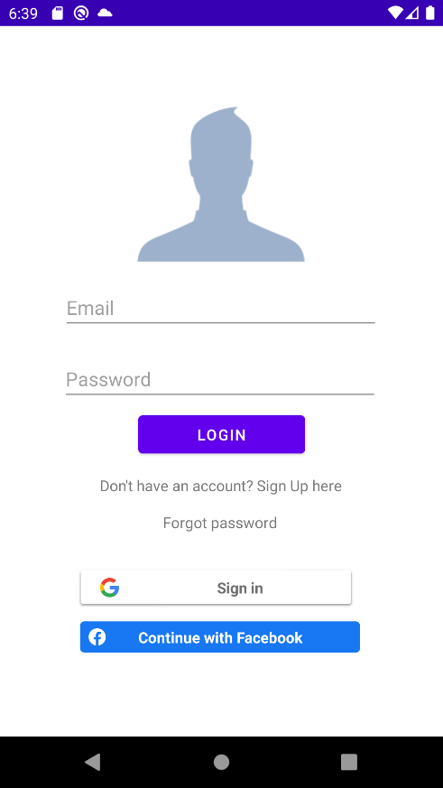

Figure 1. 2: Login screen

### 4.1.3 Sign up

This application has several login systems. Users can be registered by their own credentials, or they could use their Facebook or Google account. Sometimes users are preferring the use with their own credentials because of the security concern and some other users use their google or Facebook accounts for logins because it is easy to login and they no need to remember the username or password for this solution specifically.

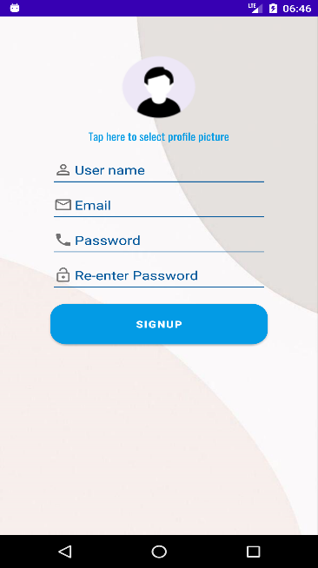

Figure 1. 3: Sign up screen

If user wants to sign up to this application from their own credentials this interface will show up to the user’s mobile application when user select the “sign up here” option in the login screen.

Users have to enter user’s name which this application get it as display name. after that user need to enter their email address. It will be the login email. Then user have to enter password. Which being used for the login. After that user will automatically login into the system and redirect to the main menu of this application. And also, users have to set a profile picture.

Password has no validations because this application is used only for the personal use only and this application does not need higher security concern for now.

User could use either one from Google account or Facebook account. This system will access only the users name, email, and their profile picture. So, users do not need have doubt about the security of their social accounts.

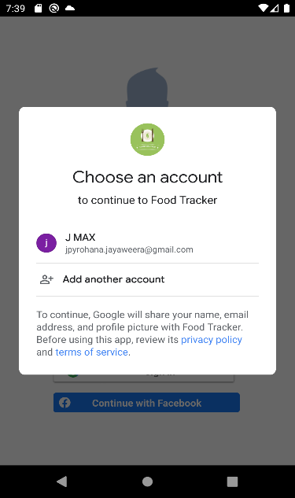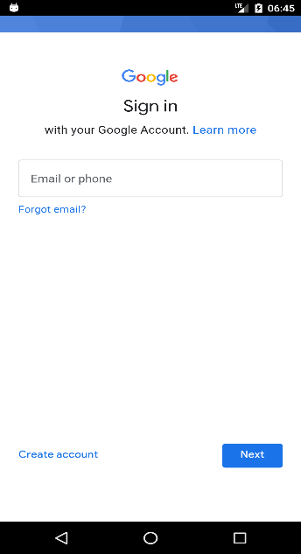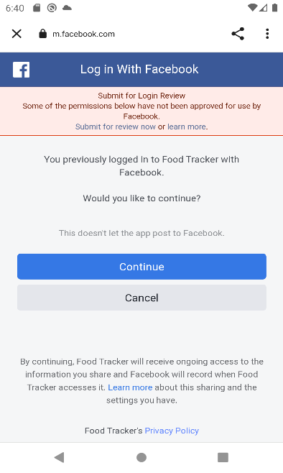

,

Figure 1. 4: Google and Facebook authenticators

### 4.1.4 Forget password

Sometime user’s will forget their password, if the user has used their own credentials to login to the system. So as a solution users can use “forgot password” option in the login screen. But the user needs to enter their email address which is used to sign up for this system. System will send an email to reset password once user enter the email that used to login to this system.

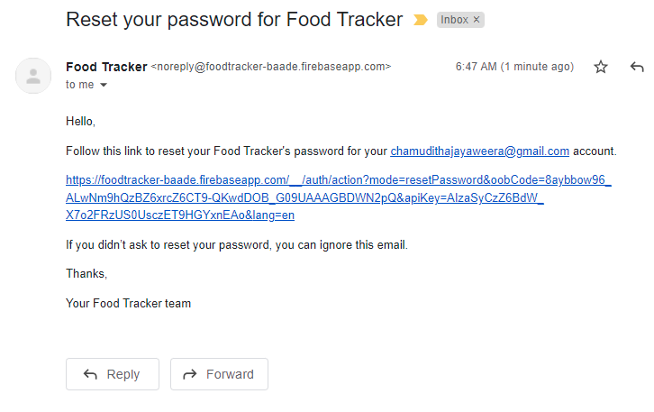

Figure 1. 5: Password reset link

### 4.1.5 Main menu

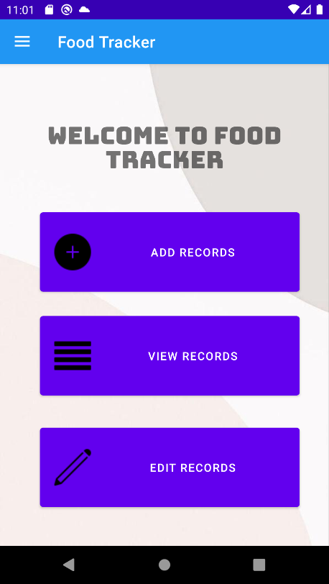Once the new user after complete signup and login process or the users who has already sign into the system will redirect Main menu.

Figure 1. 6: Main menu

In this interface user can see the basic features that users could experiences from this mobile application solution.

As the first option it has the “Add records” function. Which is used to enter food items details, that the user wanted to get notify.

Second option it has “View Records” function. Which is used to view the records that have added previously.

Last option shown in this mobile application menu was “Edit Records”. If the user wanted to edit what they have entered to list user could use this option.

### 4.1.6 Side panel/ Navigation Drawer

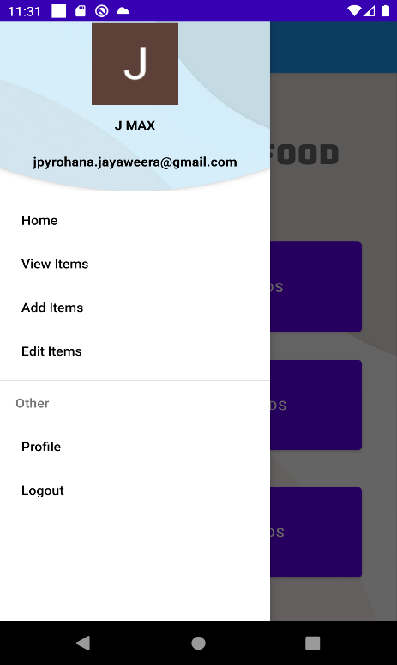

Figure 1. 7: Navigation Drawer

This side panel have been using every interface in this solution except login interface and signup interface. This side panel being used because if the user wants to move directly to another interface or option, they no need to go back to the home menu. They could use this drawer and directly switch into different options.

In the top of the panel users can see their personal details such as username, profile photo and e-mail which was given to the system when they sign up. Then there was other main option “Profile” and “Logout” options that does not showing in the main menu.

### 4.1.7 Add Records

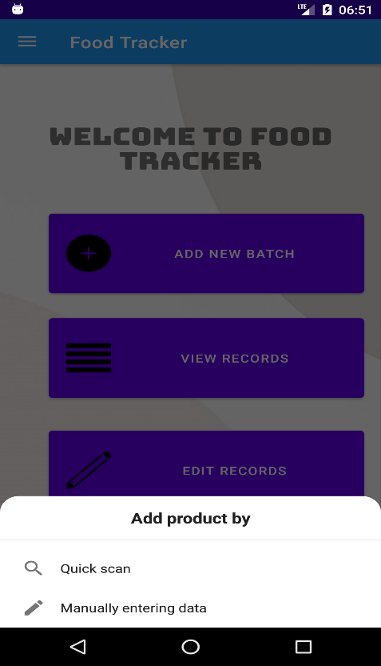

Figure 1. 8: Add Records

If the users select the add new products from the main menu, user can choose either one option from it.

In the option panel it says, “Quick scan” and “Manually entering data”. When used select quick scan function, then the system redirects to function that can add items by scanning and if the user selects manually entering data option, they could enter the items data by manually entering the details.

### 4.1.8 Quick scan

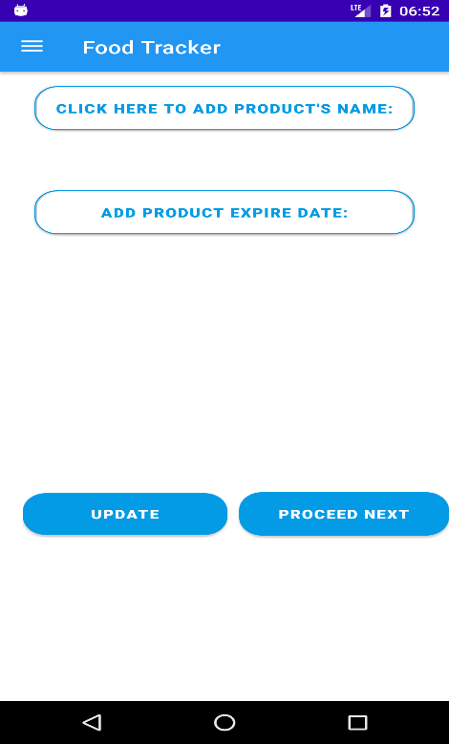

Once the user selects the “Quick scan” option from the main menu it will redirect to this interface. In here user only have to add food products name and expired date. As in the name of the option, user have to enter both those values by scanning the product. After scan the data will show under the text fields.

After entering both name and date of the product, user could add that details to list by selecting “Proceed Next” option and “Update” option being used to if the data that scanned was wrong then user could change those data in the “Edit records” interface.

When the user selects the “CLICK HERE TO ADD PRODUCT’S NAME” button, system asked for the permission to take pictures and to access the device media and files.

Once the user select “Allow”, then the mobile application could use the camera or the pictures that saved on the device.

Figure 1. 9: Quick Scan

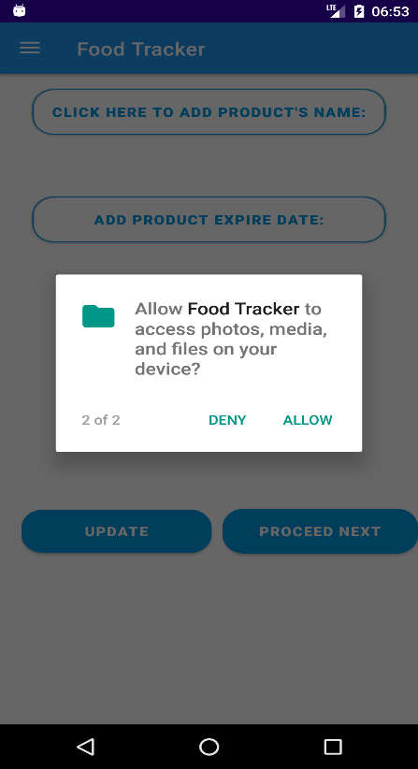

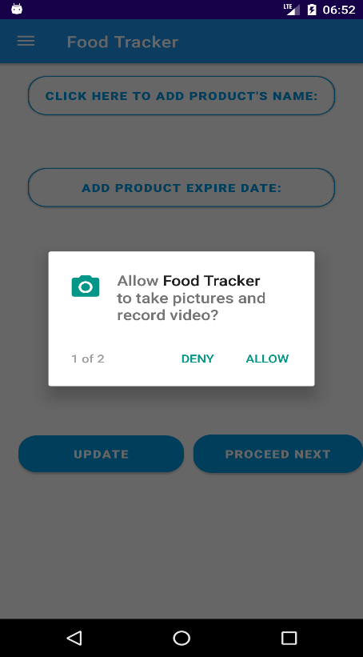

Figure 1. 10: Requesting permissions

After allowing the permission that required from the mobile application user could select one option from the pop-up dialog.

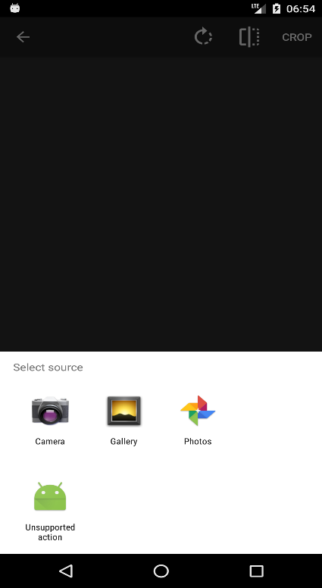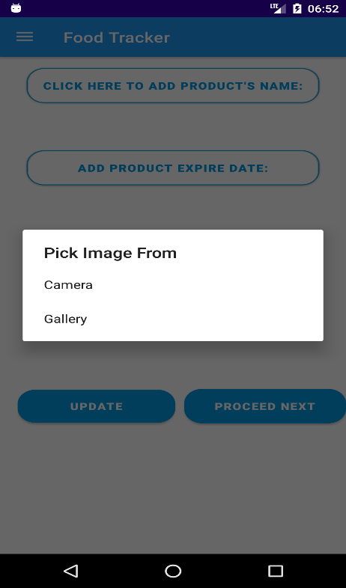

Figure 1. 11: Capture image popup

If the user has been chosen the camera from both pop-ups, then mobile application will open the camera. After user capture the name of the product, user need to crop only the selected area that should add as the name of the product.

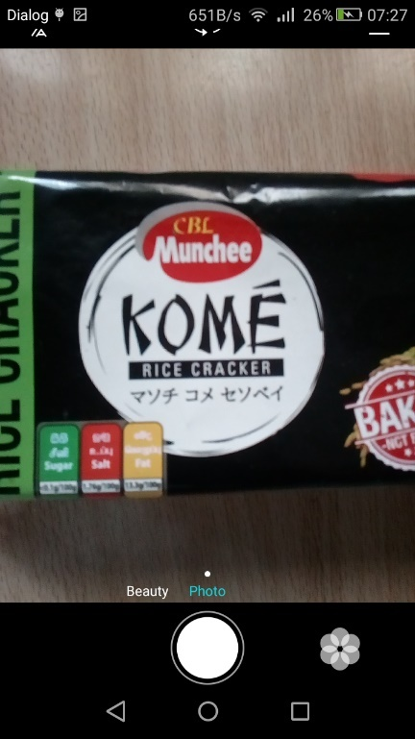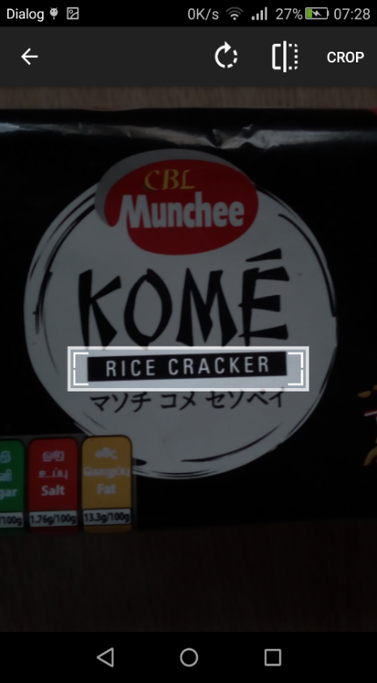

Figure 1. 12: Capture Image

Figure 1. 13: Crop Image

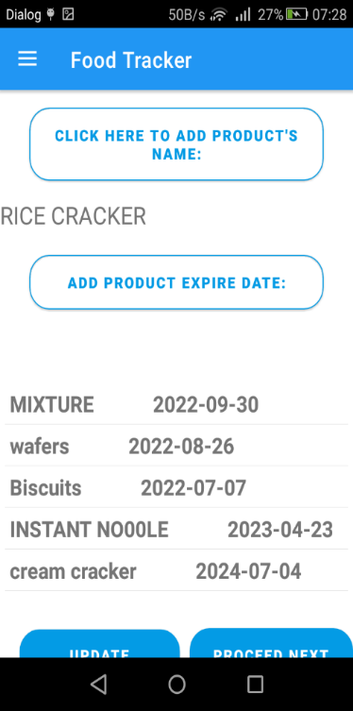

Figure 1. 14: Scan Results

After user select crop button, application give the result as a name of products below the button. As same as the previous procedure, users could add the expire date for the same product.

When user scan the date of the product, they need to clearly crop out the date that should be add to the expire date field. There should be not having any characters or numbers other than the date, or special characters. Because that input gives an error. This mobile application could accept every format of date type. So, user does not want give attention to the date specifically.

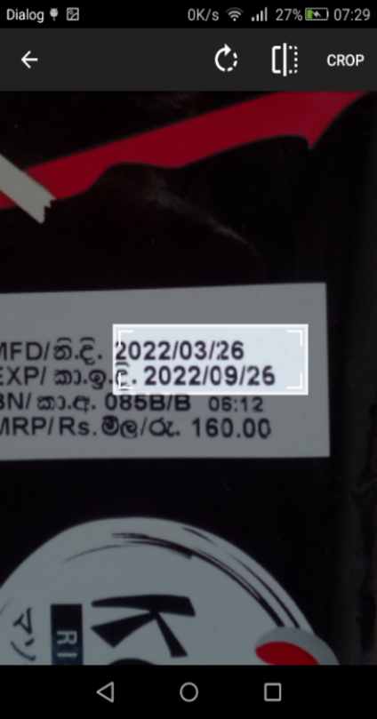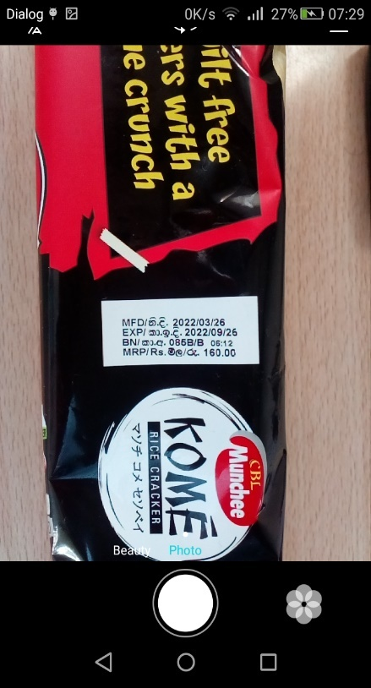

Figure 1. 15: Crop Date

Figure 1. 16: Capture Date

After scanning the image that chosen and cropped by the user, mobile application shows the result in the expire date field. Then user can select “update” option if the scanned result is wrong or otherwise user can simply select “Proceed Next”. Then application will update the list and show it in the result after the update.

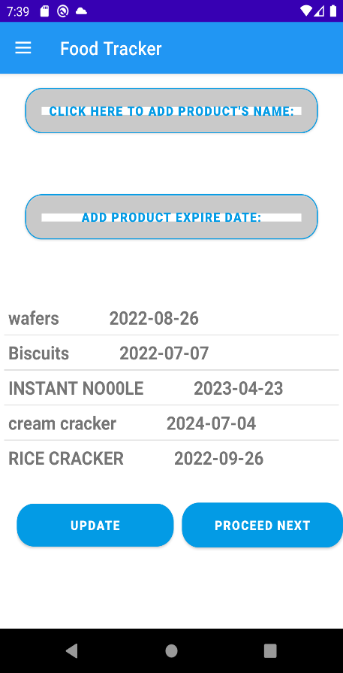

Figure 1. 17: Updated Screen

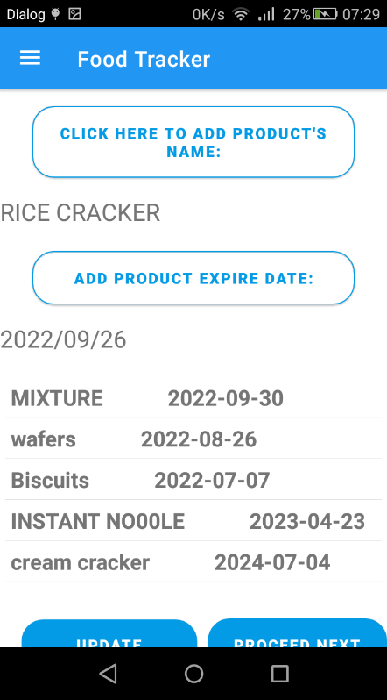

Figure 1. 18: Scan date result

### 4.1.9 Manual data insert

When the user selects the “Manually enter data” options in the main menu pop-up, it will redirect to this interface. This interface also having the same input fields as in the “Quick Scan” interface. But in this interface user have to input those criteria manually. Have to add food item name first then user should select the date from calendar. After filling those input fields use could add those items to the list by selecting “Add” button. Once item was added to the list, those input fields get empty and “Add” button being showed as “Add Another”. If the user wants change the item’s name or its expired date, user could select the “Edit Data” option next to “Add” button. Then interface redirect to the “Edit Records” interface.

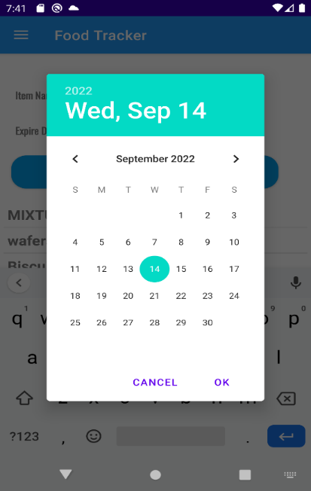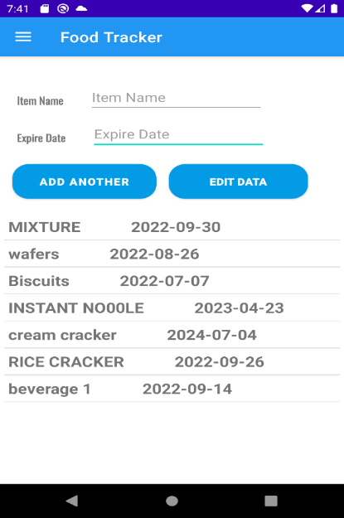

Figure 1. 19: Select date manually

Figure 1. 20: Manual data insert

### 4.1.10 View Data

This interface is used to view the items that added by the specific user. Users could see their all the items and expire date next to it. If the user wants to change the data of the specific item, they can select it and automatically redirect into “Edit Records” interface, with selected data on the input fields. User could use delete the items if those items were consumed

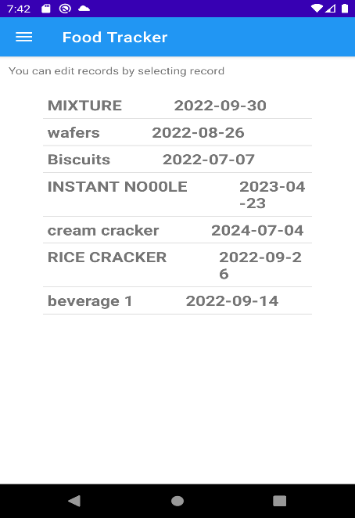

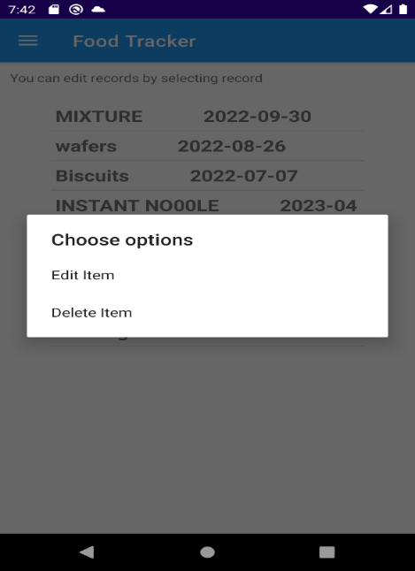

Figure 1. 21: View Data interface

Figure 1. 22: View Data Option pop-up

### 4.1.11 Edit Records

In this interface user can change their items details. It cannot access directly, user have to select one item from the View records, manually add items or quick scan interfaces. One the user selects those items, and they change the information of the products by manually.

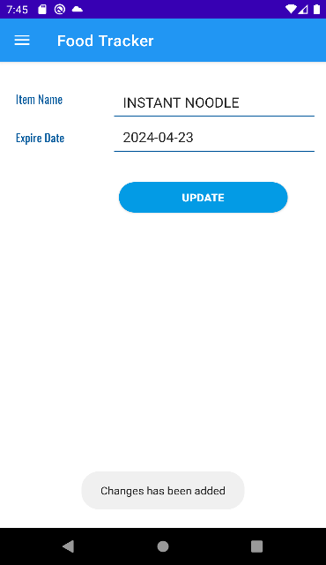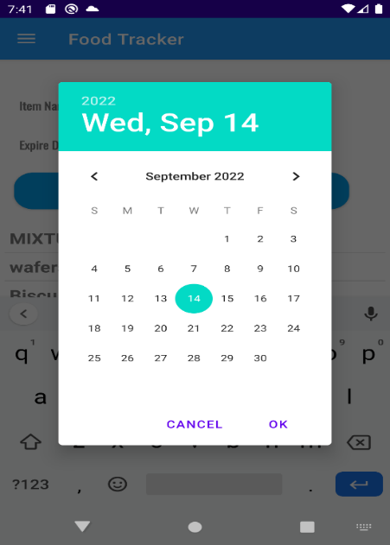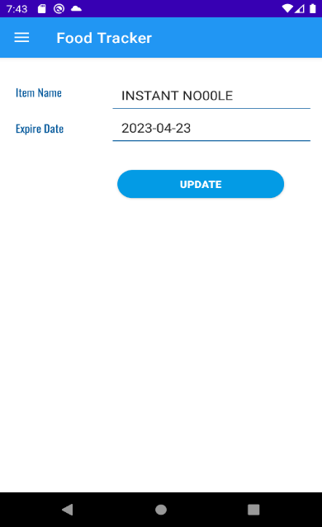

Figure 1. 23: Edit Record Interfaces

### 4.1.12 User Profile

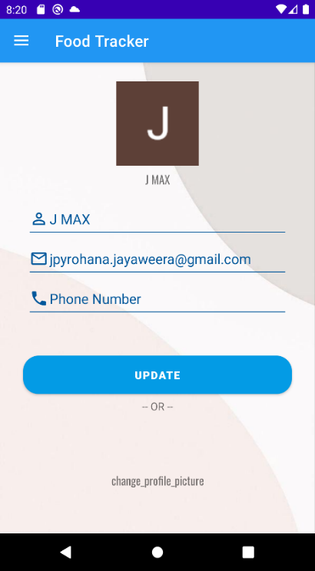

This interface give opportunity to the users to change their profile picture and display name or add the phone number.

Figure 1. 24: User Profile Interface

### 4.1.13 Notifications and alerts

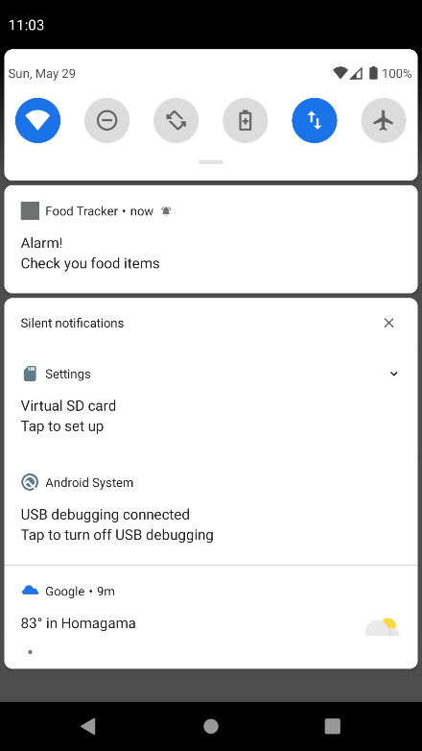

Figure 1. 25: Notification

This food tracker mobile application is based on how to stop wasting foods. So this application is basically a type of reminder. That notify the users when the foods are going to expire. As you can see it shows an alert which saying that foods are going to expire. This reminder was set up when the user adds to the items and it’s expired date to the system. And then this reminder identifies the date from user input and it set reminder 30 days before expired date.

Once the expire date is set then this reminder will show a notification to the users.

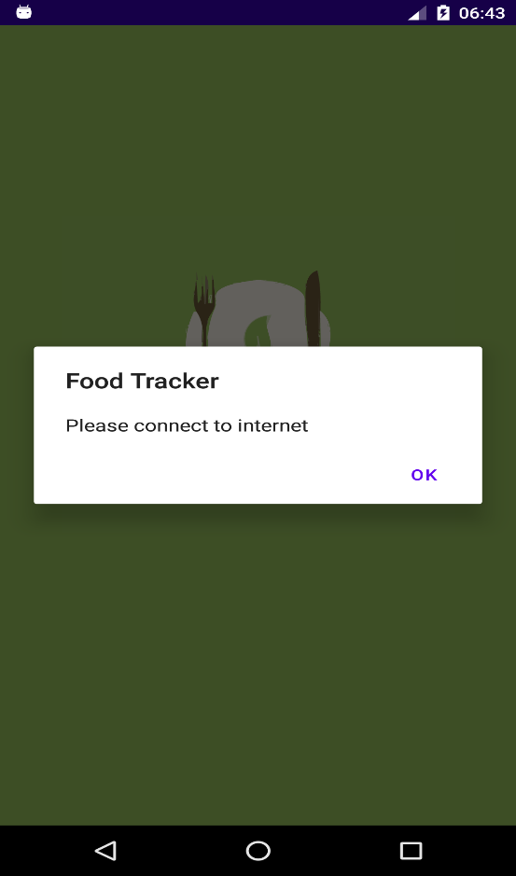

Figure 1. 26: No Internet pop-up

If this mobile application does not connect to the internet, it will shows and error message to the users.

## 4.2 Food tracker Web application: Industrial

This web application was created to the sellers or the shop owners to track their foods and products also to get notify if they are going to expire. Basically, this web application connects with a Food tracker web application that created for the sellers or the shop owners. From that mobile application can update this system. But only they can update the batch of specific item that created by this web application. Special feature of this system is web-based application can access anywhere anytime. So, the managers or the owners can simply login to this system and they can get better idea of their inventory. In this inventory management web application have several specific features as below.

### 4.2.1 Login

This screen shows the logins for the Administrators of Food tracker inventory management system. Administers have to register first. After that they can get specific login credentials to login to this system. That system is specific with each other.

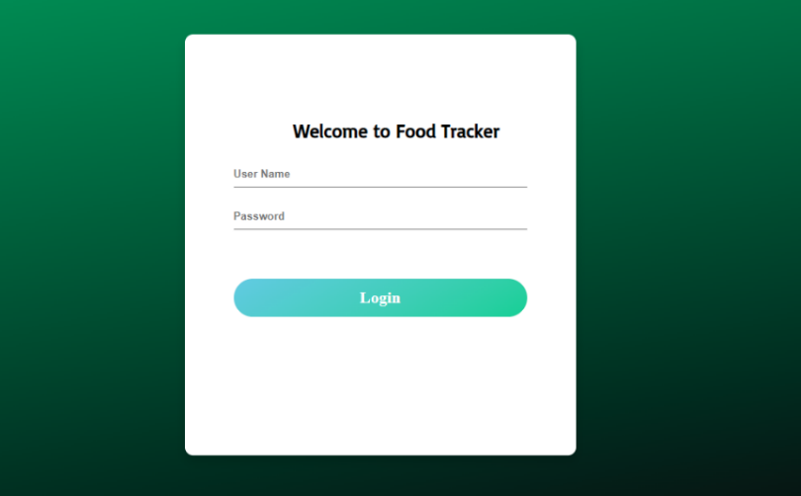

Figure 2. 1: Login interface

### 4.2.2 Alerts

Once the administrator login to the system, they can see the alerts section which is used to notify if the products or items that store in the inventory going to expired. So, he can see only the items having close expire date.

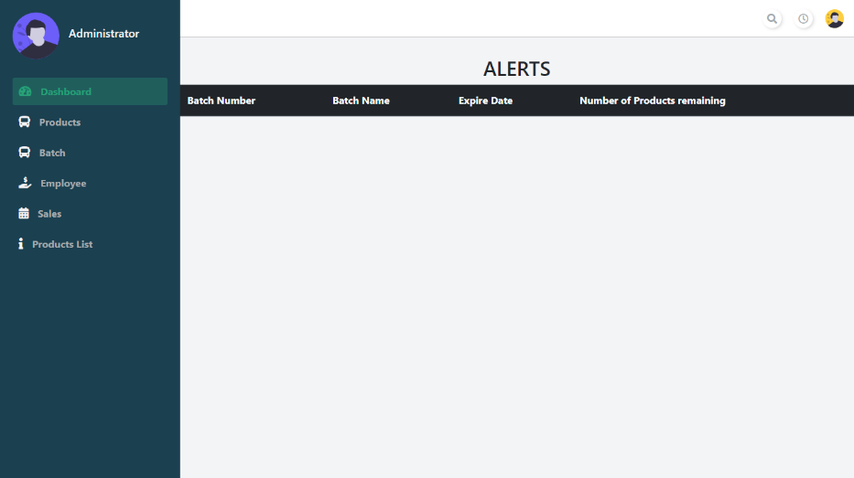

Figure 2. 2: Alert Interface

### 4.2.3 Products

In the products section administrators can add new products that have introduce to the market or the new brand that shop owners getting deal with. So they can insert that product as new product to the inventory.

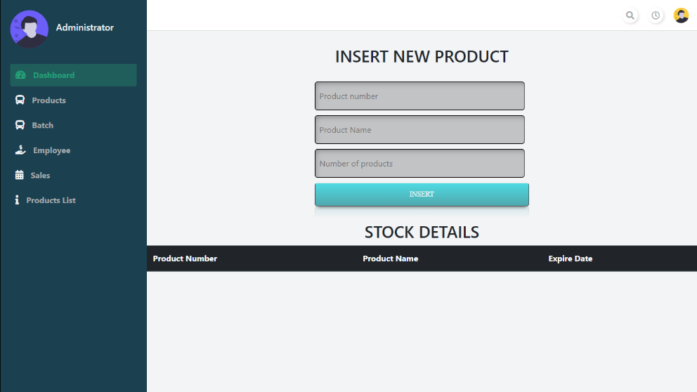

Figure 2. 3: Product Interface

### 4.2.4 Batch

Batch section is used to keep record about how many batches of a certain products are getting to the shop. Because shops getting products as batch so they need to track about those batch.

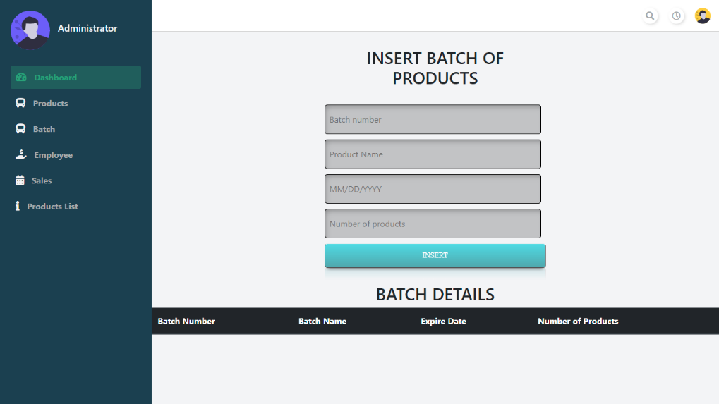

Figure 2. 4: Batch interface

### 4.2.5 Batch details

Here administrators can keep track of the batch amount of certain product.

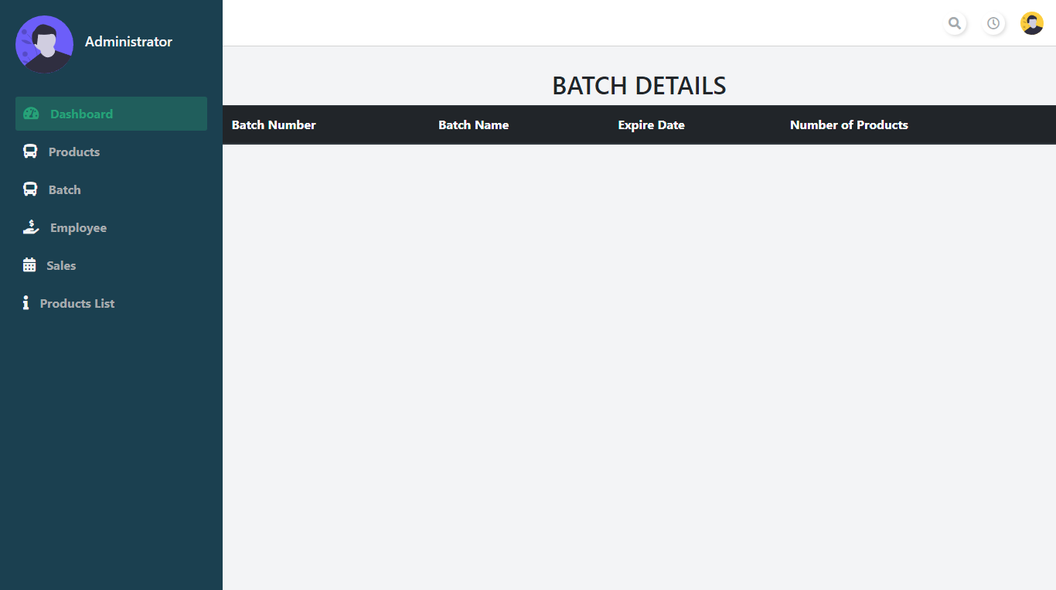

Figure 2. 5: View Batch Details

### 4.2.6 Register new employee

Only the administrators can register the users of their Food tracker mobile application. So admins can manage the activities that could affect the inventory management system.

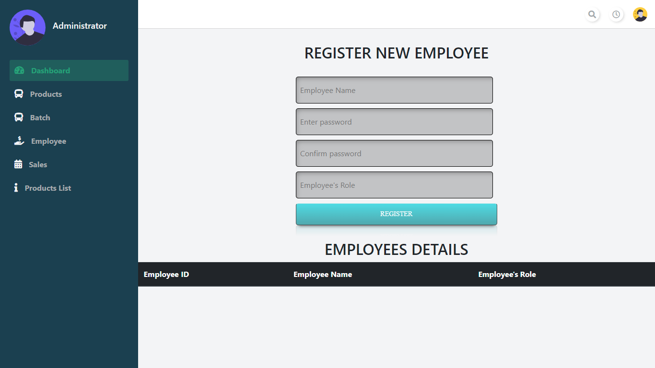

Figure 2. 6: Register new Employee interface

## 4.3 Food tracker mobile application for the industrial purpose

### 4.3.1 Splash screen/ Loading screen

The first screen users could identify in their mobile application. That include the logo of the application.

It loads 1 seconds and then it redirects to the login page. If the employee already a logged into the system, then the system directly shows the application main menu.



Figure 3. 1: Splash screen

### 4.3.2 Login

This screen shows the logins for the employees.

They cannot register by them self. So, they have to registered by the administrator of the Food tracker inventory management system. Those registered employees could login to the application by using their login credentials.

Once the employee login into the system with any login option, they do not need to enter their credentials again and again.

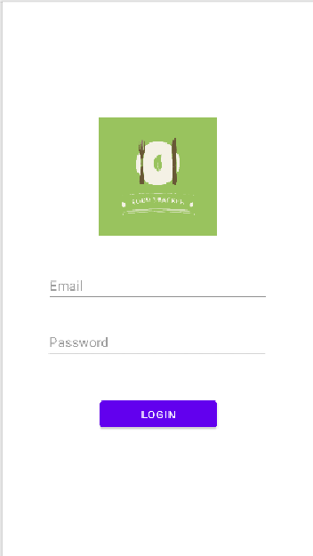

Figure 3. 2: Login Interface

### 4.3.3 Main menu

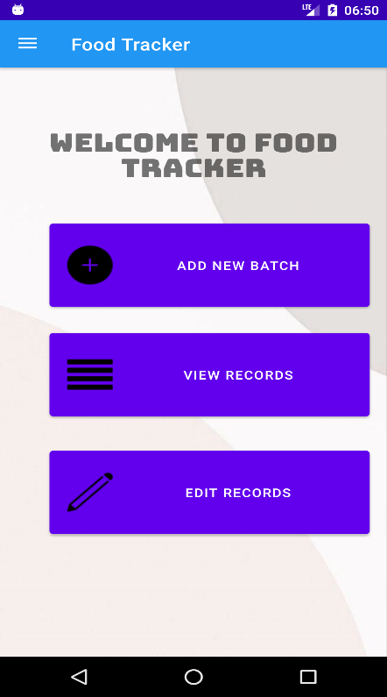

Figure 3. 3: Main menu interface

In this interface employee could access the features of the Food tracker application created for the employees.

As the first option it has the “Add new batch” function. Which is used to enter certain food’s batch details, that should update.

Second option it has “View Records” function. Which is used to view the records that have added previously about the foods items and their batch details.

Last option shown in this mobile application menu was “Edit Records”. If the user wanted to edit what they have entered to list user could use this option.

### 4.3.4 Side panel/ Navigation Drawer



Figure 3. 4: Navigation Drawer

This side panel have been using every interface in this solution except login interface and signup interface. This side panel being used because if the user wants to move directly to another interface or option, they no need to go back to the home menu. They could use this drawer and directly switch into different options.

In the top of the panel users can see their personal details such as username, profile photo and e-mail which was given to the system when they sign up. Then there was other main option “Profile” and “Logout” options that does not showing in the main menu.

### 4.3.5 Add Records

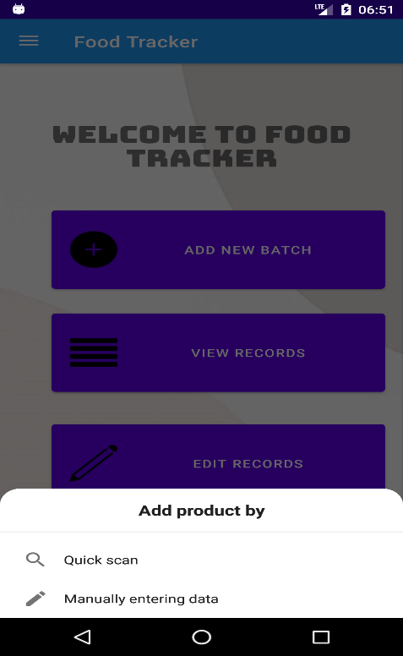

If the employees select the add new batch from the main menu, employee can choose either one option from it.

In the option panel it says, “Quick scan” and “Manually entering data”. When used select quick scan function, then the system redirects to function that can add batch details by scanning and if the user selects manually entering data option, they could enter the batch data by manually entering the details.

Figure 3. 5: Add New Batch interface

### 4.3.6 Quick scan

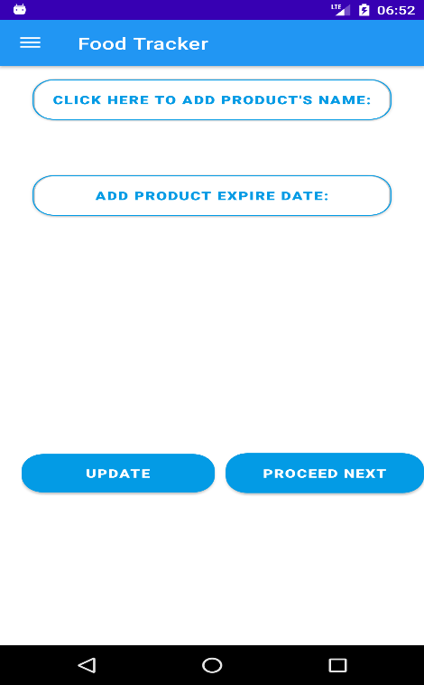

Figure 3. 6: Quick Scan interface

Once the user selects the “Quick scan” option from the main menu it will redirect to this interface. In here employee only have to add food batch number and expired date. employees have to enter both those values by scanning the product. After scan the data will show under the text fields.

After entering both number and date of the product’ batch, employee could add that details to list by selecting “Proceed Next” option and “Update” option being used to if the data that scanned was wrong then employee could change those data in the “Edit records” interface.

When the employee selects the “CLICK HERE TO ADD PRODUCT’S NAME” button, system asked for the permission to take pictures and to access the device media and files.

Once the user select “Allow”, then the mobile application could use the camera or the pictures that saved on the device.

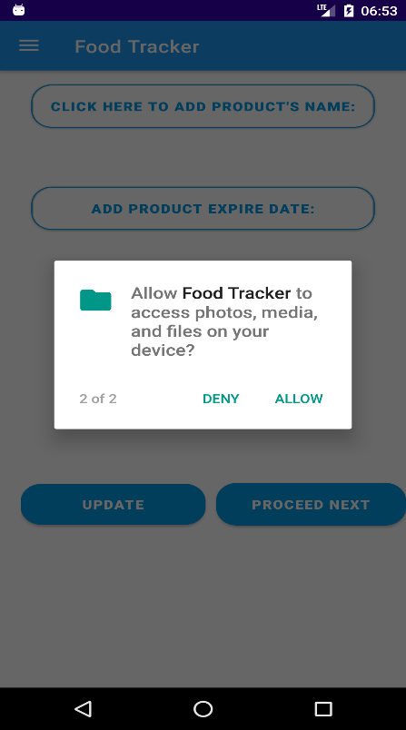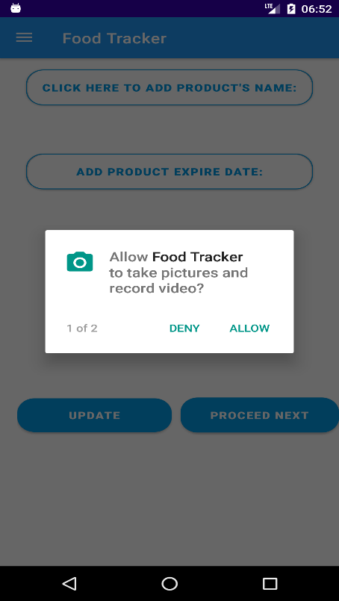

Figure 3. 7: Requesting Permission

After allowing the permission that required from the mobile application user could select one option from the pop-up dialog.



Figure 3. 8: Camera selecting pop-up

If the user has been chosen the camera from both pop-ups, then mobile application will open the camera. After user capture the name of the product, user need to crop only the selected area that should add as the name of the product.

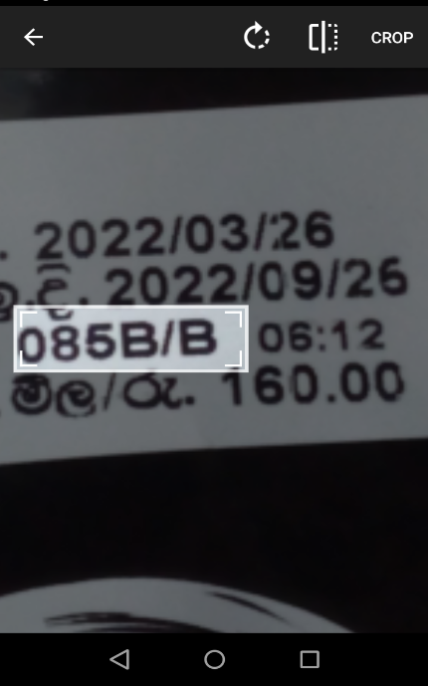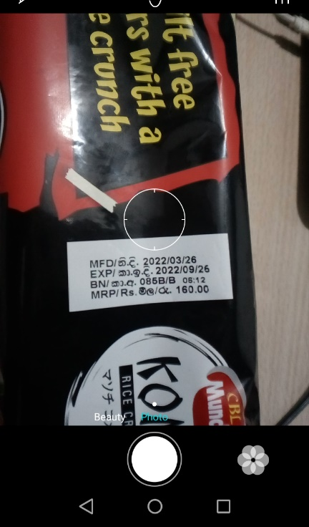

Figure 3. 9: Capture Image

Figure 3. 10: Crop the Batch Number

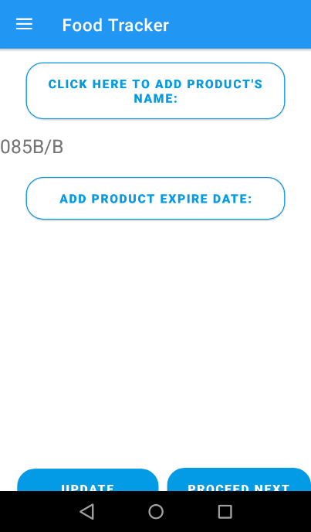

Figure 3. 11: Scan results

After user select crop button, application give the result as a batch number of products below the button. As same as the previous procedure, users could add the expire date for the same product.

When user scan the date of the product, they need to clearly crop out the date that should be add to the expire date field. There should be not having any characters or numbers other than the date, or special characters. Because that input gives an error. This mobile application could accept every format of date type. So, user does not want give attention to the date specifically.

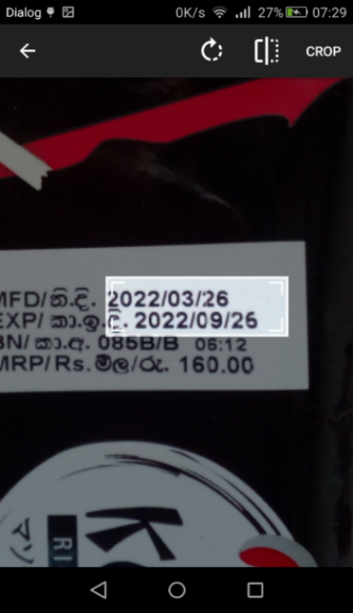

Figure 3. 12: Crop Expire Date

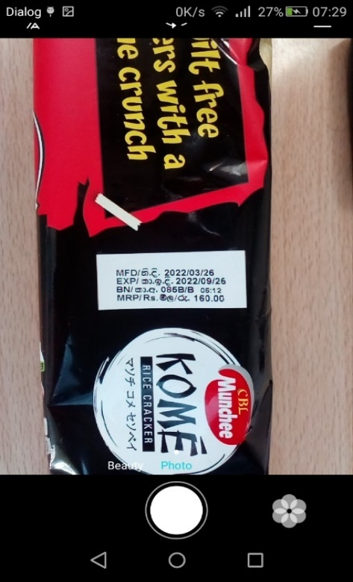

Figure 3. 13: Capture Image

After scanning the image that chosen and cropped by the user, mobile application shows the result in the expire date field. Then user can select “update” option if the scanned result is wrong or otherwise user can simply select “Proceed Next”. Then application will update the list and show it in the result after the update.

Figure 3. 14: Refreshed interface



Figure 3. 15: Scan Result

### 4.3.7 Manual data insert

When the user selects the “Manually enter data” options in the main menu pop-up, it will redirect to this interface. This interface also having the same input fields as in the “Quick Scan” interface. But in this interface user have to input those criteria manually. Have to add batch number first then user should select the date from calendar. After filling those input fields use could add those items to the list by selecting “Add” button. Once item was added to the list, those input fields get empty and “Add” button being showed as “Add Another”. If the user wants to change the item’s name or its expired date, user could select the “Edit Data” option next to “Add” button. Then interface redirect to the “Edit Records” interface.



Figure 3. 16: Selecting date manually

Figure 3. 17: Manual data insert interface

### 4.3.8 View Data

This interface is used to view the items that added by the specific user. Users could see their all the items and expire date next to it. If the user wants to change the data of the specific item, they can select it and automatically redirect into “Edit Records” interface, with selected data on the input fields. User could use delete the items if those items were consumed



Figure 3. 18: View Record options

Figure 3. 19: View Records interface

### 4.3.9 Edit Records

In this interface user can change their items details. It cannot access directly, user have to select one item from the View records, manually add items or quick scan interfaces. One the user selects those items and they change the information of the products by manually.



Figure 3. 20: Edit Records interfaces

### 4.3.10 Notifications and alerts



Figure 3. 21: Notification Alerts

This food tracker mobile application is based on how to stop wasting foods. So, this application is basically a type of reminder. That notify the users when the foods are going to expire. As you can see it shows an alert which saying that foods are going to expire. This reminder was set up when the user adds to the items and it’s expired date to the system. And then this reminder identifies the date from user input, and it set reminder 30 days before expired date.

Employees also getting a notification if the products are going to expire.

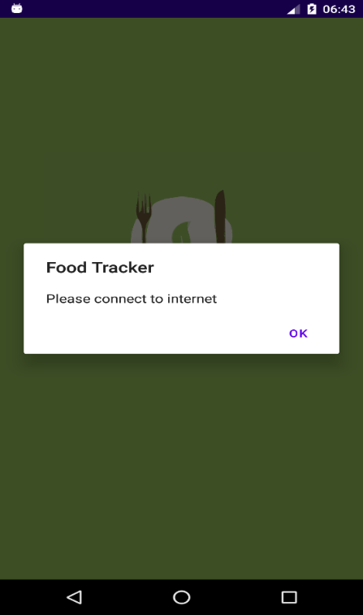

Figure 3. 22: No internet pop-up

If this mobile application does not connect to the internet, it will show and error message to the users.

# Methods of approach

Methods of approach means how the project is managed to complete within the time period. For this project the author used the waterfall development method. Which is most traditional way of implementing a solution. This waterfall method is linear model that consists of sequential phases (requirements, design, implementation, verification, maintenance).

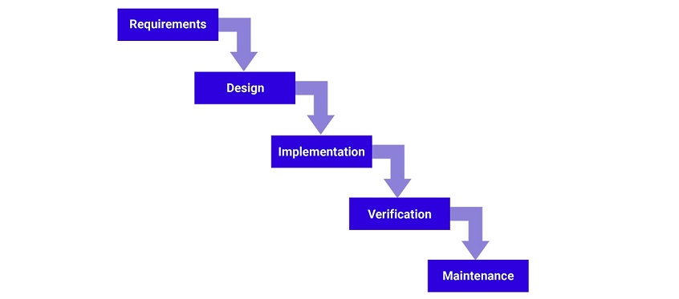

Figure 4. 1 Waterfall development method

So how the waterfall methods have been applied to this solution when implementing. First the author gathers the requirement for this solution. Like what are the problems how the problems forming, what are the resources that should apply when creating the solutions, what will be barriers that author has to face. After analysing those requirements then move to next stage of the waterfall method, which is design stage. In that implementing stage author have to get better view of this whole project. Solution was dependent on that matter of those decisions. So, the author used to create this solution based on the popular and widely using technologies like android. Then for the industrial use solution was created based on web application. All with that author moved to next method in the waterfall development method. Implementation was the hardest part of this method. Because it was changing rapidly with the supervisor advice and solution had to make under high pressure. It took more time than it was planned. Now it is on the verification stage. That has to be approved from a panel of judges.

# Requirements

There are some specific requirements have been identified by the author when designing the solution.

1. Identifying objects using OCR techniques.

How this application should be different from other apps. It should use unique technique, like Optical Character Recognition technique. It can identify characters by scanning. So how to implement application with this technique, what are the area that can cover with this technique. When implementing this solution with this technique author had to face with different mechanism. Like live OCR mechanism and 3rd party OCR libraries. There are several ways to implement this technique and for this solution author has selected best and accurate mechanism is being used.

1. Real-time databases

In this solution there are 2 types of separate target. One is domestic users and other target is industrial users. So how to maintain both of there database. This solution required fast and real-time respond. For that author used firebase technology when developing this solution. By using that firebase technology, could exchange data with server in lower latency. Food tracker solution that was used for the industrial using having more value to this real-time database technology.

# End project report

## 7.1 Summary

In these days, people are busier with different matters. People does not pay special attention to their foods. And they do not have much care about the food they bought from the supermarket or shops or specially their expire dates. Nowadays people used eats junk foods or instant foods. Other than that, foods some are used to be healthy. So, they are only consuming healthy food products. But use of that healthy products they have to pay attention on their quality. So, when talk about the food quality, it is dependent on the foods expire date. But with this restless busy lifestyle they cannot give separate attention for that kind of information. Therefore, if the food products are expired, they cannot consumption. we can take it as a food wastage.

Fact, people are more familiar with mobile phones rather than the few years ago. By taking that as an advantage we can use mobile devices to give an update to the people about their foods.

So, from the mobile application user get notifications whenever the foods getting near to expire. Not only notification but also user can view different types of reports that analysed from the food item purchases from the stores. So, with these features we can save certain amounts of foods and money from wasting.

## 7.2 Business objectives

there were few main points to consider when developing this solution. Basically, this project was based on the “How to reduce food wastage”. It is huge problem rise all around the global. Food wastage can mainly affect the environment pollution and can be threatened to the many living species including the humans. So other than that matter, there are hundreds of thousands, or millions of people are dying because of the hunger and malnutrition. This solution can take as a first step to avoid this crisis by managing foods correctly in our own home. For archive this milestone, we can name some of our business objectives as below,

1. To save the foods without wasting and give better understanding about food wastage.
2. Reduced the amount of money that waste from food waste.
3. Remind the users if the foods that are not consumed, are going to expire.
4. Manage the foods accordingly.

## 7.3 Objectives, Achievement and changes made during the project

On this project there are few main project objectives should have to consider. Other than that, this project is about a solution for food wastage. Then we have to consider what must be done for the archive main objective of this project. Below are some main objective points, have been considered when developing this solution.

### 7.3.1 Category of the products that can be applied to the solution

When considering food wastage, all the food products wastage are not same. They are different in different reason, such as dried foods or the grains are last longer than the vegetables or fruits. And when talk about food packing, people cannot store some foods in refrigerator. Or otherwise, cannot store in a direct sunlight. That will directly affect the food product quality. So, it can have shorter time period to expire than the expected. Which means there may be an unexpected change due to the natural causes. As a good productive project solution, it has to analyze what type of foods that can be waste without knowing the user. When we take an example, Fruits are ripe quickly normally the customers are may consumed it, but if the customer does not consume and keep it refrigerator it may can keep fresh for several days, but if the customer does not keep that same item in refrigerator, it may be turn into food waste. So, in that case when developing the solution need to find out which product can be waste more quickly with various environmental conditions. As an example, when customer brought an apple from the market and if he/she decide to store in refrigerator it will keep fresh or keep it without wasting it for several days other than the leave it in outside.

As a project objective I had to identify what are the solution when customers add these kind of food products to their product list. It is an uncontrollable issue that have face when developing this project. Because from this solution cannot control how the user’s store food item in their place. Therefore, this type of issues I have go through the all the kinds of food items that will affect environment factors and give an average time period for each of the food item.

### 7.3.2 Data storage and database management

As a solution for the enterprise level or for shop use, it has to be a complex but also a real time inventory system. It can’t take time to make changes or updates. So, it has to be simple and easy method when developing this solution. Therefore, how I can manage the data flow of the whole system. And the main other thing that have to consider is how the large-scaled supermarkets made and maintain their products. Because they are having a large amount of product brands, products categories and also, I had to identify how they are handling if the new products launch, or new products brands released to the market and how they manage to update their existing solution’s products database when price changes, because this solution also have to keep the data that effect every item and it also have to be a real time solution.

Another important point of this solution is that different from the existing system is having a mobile application for the enterprise level or the medium level shop owners which they can control their inventory management from the mobile application, but they only have access only to update the products details.

For this solution I took firebase real-time database type and use of NoSQL database I can managed to save data without collapsing and full efficient way. It also having some main benefits like time latency is very low. Which means it takes few seconds to make changers and database queries are faster than the SQL queries.

### 7.3.3 Analysed potential development technologies and deployment solutions.

For this solution there are mainly two types of targeted users, and they may be having different operating systems. One types of users are the customers. Which is basically type of audience this solution is targeting for. And other hand this project is supporting the shop owners. When we talk about the customers or the main group of target audience, we can assume most of the people are using android operating system based mobile device. So, getting that as an advantage I developed this solution for the android operating system-based devices. Then I made database connectivity for the mobile application by using firebase database. It is the fast and easiest way to connect mobile application with the mobile database. Other than that, this solution’s mobile application using an Optical Character Recognition system. Which means capturing items and identifying them. For that, customers can already use their mobile’s camera.

The other target user is the shop owners or sellers. Nowadays most of the shop owners or the sellers are using technology. By getting that as an advantage in this solution I created web application for the inventory management which can run on any device that connected to the internet. And also, for the employees or the sellers has a mobile application. Which can used as insert products details as batch to the inventory system by scanning them. it used the same technology as used in the customers or the normal user’s mobile application. Optical Character Recognition also known as OCR technology give simple, better, and easy solution for the users without wasting their valuable time and effort. Basically, the mobile application that introduced for the sellers is implemented for the android devices. Because sometimes mobile device is a powerful and cheaper device when comparing to the other devices like barcode scanner, or the scanners only device. So, it can be a good opportunity for sellers or the owners to get their business with new technology. Other main byproduct of this solution is the inventory management system. Which is developed as a web application. Sellers or the shop owners can log on to their system anywhere at any time, which gives better opportunity like, owners or the store managers can get latest updates of products in real time. They can decide any decisions from the information that getting from the inventory management system. When connecting both seller’s mobile application and inventory management system I used firebase real-time database to low latency result. It is NoSQL database system that can be easily manage and process.

### 7.3.4 Implemented the new mobile application for domestic user

This product is a solution for stop the food wastage in every household. When talk about household food wastage if the whole family engaged with different activities like jobs or education or something like that, there is a lot of chance to forgot and not giving enough attention to the stored food. So, this solution could be do a huge change for those families. Only they have to do is take few minutes and scan the products then add into the list of their mobile. Once the food was added to the mobile application it will take a date and give users a notification prior to the expire date. From that user could use those food items or ingredients before it was expired. In the mobile application there are only having a several basic operations which is user need to add item, then they can edit or update if it is having wrong details. And they can view what are the foods stored in their home at anywhere.

### 7.3.5 Real time mobile application and that connected with the inventory management system shop owners

As described in the above there are three major solutions have invented for the reduce or stop the food wastage which is major problem that entire world is secretly facing. One application for the shop owners to manage or keep track on the inventory and maintain their sales. Other product of this solution is mobile application for sellers that connected with their inventory management system. Which helps to manage their foods. In shop owner’s application it could store food items data and it could manage to identify the expire dates of the products. From the mobile application that created to the sellers are having the Optical Character Recognition (OCR) technology that can scan the product and extract details from the products. All these should be done under less amount of time. It should be not wasting customers of shop owners or cashier’s valuable time. As summery of these two solutions once the mobile application update or inserting new data in the real-time administrator or the inventory management system can access those data

# Project post-mortem

## 8.1 Future enhancements

This solution only the basic operations like insert data, delete data, and update data. By adding some more feature like artificial intelligence or machine learning for this product, then it can be make decisions for the seller or the shop owners.

1. Inventory management system can be improved to point of sales system.
2. Better and easy to use user interfaces.
3. Compatible with other operating systems.
4. Make an attractive more feature in the mobile application.

# Conclusion

Food tracker is a solution that was introduces for both domestic and industrial users. Main target of this project is reduced or stop the food wastage. By correcting the small pieces that were being reason for the small problem, could stop whole disaster. So, if this solution used by thousand people and managed to reduce or stop the food wastage by household wise it could affect as millions of other people with saving money, foods for them. Otherwise technically the author learned new knowledge about machine learning by implementing this solution.

After all these implementations, this solution has great productivity. Which could save the humans time and money. Wasting foods are like wasting money so if this solution can stop the food wastage, eventually money also will save without wasting.

# Appendices



School of Computing and Mathematics

PRCO303

Final Stage Computing Project

INTERIM Report 1

BSc (Hons) Software Engineering

J. P. R. Chamuditha Jayaweera

Food Tracker

Supervisor: Mr. Iman Ashley

2020/2021

Table of Contents

1. Introduction 3

2. Business Case 4

2.1 Business Need 4

2.2 Business Objectives 4

3. Project Objectives 5

4. High-level diagram 9

5. Task undertaken and outcomes 10

6. Products produced and product quality 11

6.1 Login 11

6.2 Registration 11

6.3 Confirmation 12

6.4 Main menu 12

7. Risks that have materialized and your responses, changes to the risk list 13

8. Schedule 14

7.1 Project Plan 14

9. Resources 15

10. Learning undertaken and Required 16

Appendices 17

References 17

Proposal 17

PID 20

Meeting minutes 27

# Introduction

Food is thing that if one can get and other cannot afford it. Some can get more food and other can’t have much. Most of the peoples are busy these days. They are not much care about the things other than themselves. So, people have forgot that little things that can be a huge problem as an example we can take food waste. Which can define as foods that discarded by the consumers. If we simply go through that we can refer food waste as, the foods or foods product that buy from market and discard or throw away without consume. That is not much big problem for the one single human, but it will be uncontrollable environmental matter which cause by the environment pollution. How can be that environment pollutions occur? It is caused by food wastages that we throw away fills with greenhouse gas also known as methene. And un-reclaimed phosphorus in the food leads further mining. This food waste can also be a reason for environmental effect on agriculture, by reducing the total amount of water, land, and other resources.

In the other hand food is basic need of a life. But there are countries which are suffer from the famine. One country’s people waste foods and some other country’s peoples are dying for not having enough foods for consumption. one in nine people do not have enough food to take, that’s 793 million people who are undernourished. if we manage it correctly, we can fair to all the people living around the world. When we are talking about the food wastage in numbers one third of all food produced is lost or wasted. Around 1.3 billion tonnes of food, costing the global economy close to $940 billion each year. The 10% of the greenhouse gases are come from the foods that is produced, but not eaten. If food waste was a country, it would be the third biggest greenhouse gas emitter after the United State of America and China. In those greenhouse gases which mainly contain methane, are 28x stronger than carbon dioxide.

As mentioned above we can help to protect our environment that cause a huge global problem by following simple rules. In the last two years’ time people are changed with pandemic situation and move on with new technologies. So how can be this revolution can change the food wastage. Most people are busy with their day-to-day life activities, work or education, family, or various activities. but the people never refuse to go through their mobile phones, laptop or any smart devices. Even they have a very busy lifestyle they spend at least small amount of time with their mobiles. Some people used smart devices just for browsing social media or internet and some of them are used to do their daily work. So, without wasting a time on social media how we can referral people to save the earth. We could get the biggest chance having the pandemic, which is now the people love to be using the technology other than the manual or old systems or methods.

Nowadays most of the shops/supermarkets are introduced their own brand mobile applications. Or they are selling products through the online food ordering companies and online web sites. So, there are lots or customers are using these facilities through their smart devices. and for those people can use mobile application which remainder if the customer’s bought foods are going to expire. And, by without wasting those foods, can use as an ingredient to make different foods. In these days, people are more care about foods calories and the energy amount contained in the foods. So, from this application user or customer will be able to get information of the calorie in their foods. They can get different food recipe according to the foods, that they owned according to the energy’s foods have. When these mobile application users are raising the amount of foods, that can be save without waste also raise. Personally, mobile application can be an advantage in many ways. It can help user’s health, financial, and creativity. From this mobile application can focus the users to make different kinds of food according to the different recipes. It can help to enhance the user’s creativity. Otherwise, when we manage our foods without wasting and get maximum use of foods it saves the money.

As a summary Food tracker is an application for most of the people who are struggling to manage the foods. It not only the mobile application for food management. It can analyse and suggest food items to users. And users can get a report of their consumption and wastages, based on their purchased food items. This project contains a system for the shopping markets. Its basically having the loyalty system, which they can track their customers purchased items. This solution will be a better answer for the huge amount of food wastage and environment pollution.

# Business Case

## 2.1 Business Need

In these days, people are busier with different matters. People does not pay special attention to their foods. And they do not have much care about the food they bought from the supermarket or shops or specially their expire dates. Nowadays people used eats junk foods or instant foods. Other than that, foods some are used to be healthy. So, they are only consuming healthy food products. But use of that healthy products they have to pay attention on their quality. So, when talk about the food quality, it is dependent on the foods expire date. But with this restless busy lifestyle they cannot give separate attention for that kind of information. Therefore, if the food products are expired, they cannot consumption. we can take it as a food wastage.

Fact, people are more familiar with mobile phones rather than the few years ago. By taking that as an advantage we can use mobile devices to give an update to the people about their foods.

So, from the mobile application user get notifications whenever the foods getting near to expire. Not only notification but also user can view different types of reports that analysed from the food item purchases from the stores. So, with these features we can save certain amounts of foods and money from wasting.

## 2.2 Business Objectives

As business objectives there are few main points to consider when developing this solution. Basically, this project is based on the “How to reduce food wastage”. It is huge problem rise all around the global. Food wastage can mainly affect the environment pollution and can be threatened to the many living species including the humans. So other than that matter, there are hundreds of thousands, or millions of people are dying because of the hunger and malnutrition. This solution can take as a first step to avoid this crisis by managing foods correctly in our own home. For archive this milestone, we can name some of our business objectives as below,

* To save the foods without wasting and give better understanding about food wastage.
* Reduced the amount of money that waste from food waste.
* Remind the users if the foods that are not consumed, are going to expire.
* Acknowledge the users how much spent on their food items.
* Manage the foods items accordingly.

# Project Objectives

On this project there are few main project objectives should have to consider. Other than that, this project is about a solution for food wastage. Then we have to consider what must be done for the archive main objective of this project. Below are some main objective points, will have to consider when developing this solution.

1. To analyze the foods or the products which are wasting with weather conditions.

When considering food wastage, all the food products wastage are not same. They are different in different reason, such as dried foods or the grains are last longer than the vegetables or fruits. And when talk about food packing, people cannot store some foods in refrigerator. Or otherwise, cannot store in a direct sunlight. That will directly affect the food product quality. So, it can have shorter time period to expire than the expected. Which means there may be an unexpected change due to the natural causes. As a good productive project solution, it has to analyze what type of foods that can be waste without knowing the user. When we take an example, Fruits are ripe quickly normally the customers are may consumed it, but if the customer does not consume and keep it refrigerator it may can keep fresh for several days, but if the customer does not keep that same item in refrigerator, it may be turn into food waste. So, in that case when developing the solution need to find out which product can be waste more quickly with various environmental conditions. As an example, when customer brought an apple from the market and if he/she decide to store in refrigerator it will keep fresh or keep it without wasting it for several days other than the leave it in outside.

As a project objective I have to identify what are the solution when customers add these kind of food products to their product list. It is an uncontrollable issue that have to face when developing this project. Because from this solution cannot control how the user’s store food item in their place. Therefore, this type of issues I have go through the all the kinds of food items that will affect environment factors and give an average time period for each of the food item.

1. To analyze and figure it out how the shops/supermarkets databases save the information’s of the products.

In the large-scale supermarket, they are having a huge range of products in different categories. Also, they maintain loyalty membership which track their customers purchases and used analyze their sales. When we take an example in the fruit category their may be apple and that can be categorize into different types. And for each type they valued different prices. Likewise, there may be complex and unique database system owned by large supermarket or shops. When we take a single grocery store, they may only have the basic point of sales system. For that kind of issue, we have to install this project solution’s point of sales system to maintain loyalty customers database. Or otherwise, customers can use their mobile device and add each product by themselves. And those stored data have to use for the analyzing. Those analyzed data can be used for both customers and the shop owners. So the solution database should be created to help the analyzing part as well.

As a summery, in this solution also have to figure it out how they manage to store data in efficient way and what are the areas they area collecting the data about. Because if we take on food category, there might be hundreds of types of foods in a single category. So, it has to be done in very efficient way. For this solution, it has to find out the expire date of each product. But it can be different with same type of food items. So how could be save data or used data to represent.

1. To analyze potential development technologies and deployment solutions.

For this solution there are mainly two types of target users, and they are having different operating systems. One types of users are the customers. Which is basically type of audience this solution is targeting for. And other hand this project is supporting the shop owners. When we talk about the customers or the main group of target audience, we can assume most of the people are using android operating system based mobile device. So, getting that as an advantage I can develop this solution for the android operating system-based devices. And for the database connectivity of the mobile application can made up with a firebase database. It is the fast and easiest way to connect mobile application with the mobile database. Other than that, this solution mobile application uses an Optical Character Recognition system. For that, customers can already use their mobile’s camera. In the back end I have to use several libraries for that.

On the other hand, shop owners generally using a Microsoft windows operating system-based computer or else some shop owners can use a Linux operating system-based computer. So that situation it is better to use a programming language that operating system independence. Java is the best solution for that kind of situation. And java will be more advantage to here because of the customer’s mobile application. In this point of sales system also have an Optical Character Recognition system for identify the product details such as product id, product expire date, manufacture date, or that kind of important data. Other than the optical character recognition method, it has basic functions of point of sales system. Such as transaction, which used generate sales receipt, and then it has inventory management ability for adding, updating or else removing the products from the database. When talk about the database whole system database has to store in separate server. There are different reasons for that. Mainly reason for that can be describe as the database’s protection. If the data are stored in the shop and there is a environmental cause disaster like fire or earthquake or the human cause disasters like robbery or data breach can damage or destroy valuable data. And the second reason to host database in separate server is, this project is syncing with shop owners and customers details. For example, one customer may be a loyalty member of several shops, but he still has to get products details from those shops. Because of that data cannot be saved in local database. It should be definitely host in a server.

1. To implement the new mobile application for customers and POS software for the shops or supermarket.

In this solution, there are two main parts for the project. One application for the shop owners to manage or keep track on the customers and for manage the sales. Which can describe as Point of sales. And the other product of this solution is mobile application for customers. Which helps to manage their foods. In shop owner’s application it should store food items data, customers data and it should manage to identify the expire dates of the products by Optical Character Recognition (OCR). All these should be done under less amount of time. It should be not wasting customers of shop owners or cashier’s valuable time. As summery of this solution’s point of sales system is it can do the transactions which are done by the customers, keeping the purchased records of each loyalty customers, identify and save the data like price, expire date, manufacturing data by using Optical Character Recognition system implemented, transfer saved data into the loyalty customers mobile application right after the purchased, generate analyzed sales reports according to the records the customers purchased.

Other than that, on customer’s mobile application should generate analyzed report for the each of purchased or according to the certain time period. Then he/she can identify different areas that should concern about. As an example, customers can get better idea what they bought most in the certain time and what are the food items that waste more in a certain time period. Other than that, analyzed reports should identify the regularly consumptions and notify the users, if they are not having in the customers or the user’s food list. Then he can get acknowledge and buy those products. Not only the analyzed report but also in the customers mobile application they can add food products or different items by themselves manually. Which means if customers buy some foods items from the store that does not using this project solution’s point of sales system, still customer can add manually those bought products. For that mobile application should also have a method to add it manually. Therefore, it can used Optical Character Reading method, which give user’s an easy method add to product list. And customers can add items manually entering values. Then customers or users can change the product details or delete item. Not only those features, but the main feature of this solution is also when the customer buy items from the store or supermarket that having the project solution’s point of sales system, after the purchase those products are automatically adding to the customers products list. So, customers never have to spent time on adding items to his product list. Another feature of this solution’s mobile application is the notifications. Those notifications will pop-up with according to the expiration of each product. It will notify if the item is near to getting expire. For the greater user experience, there will be setting section that user can change notifications preference according to their willing. There will be like how it should show as a message and notification sound. By personalize those settings, customers or users can easy and get greater experience from this mobile application.

1. To provide real-time mobile application and POS for the customers and the shop owners with a correct data.

This food tracker application is design to retrieve purchased data from the shop owners point of sales system. By that user does not want to add manually to their item list on the mobile device. For that instance, I have to use database that work as a real-time. as a solution I choose firebase database which is simple to use and can get quick responses after the database update. Real time is a major point for this application. Because right after the customers purchases, it has to be added into the personal item list with the products expire date. Other than that firebase is a most suitable database system for the android devices. By this point customer will get better real-time mobile application experience.

Other than the food tracker mobile application, there is point of sales system for the shop owners also. For that type of application, it should be better to use a normalized database. Because there are many types of products to handle. And need fast response and reliable. So, SQL related database can be best for this type of situation.

# High-level diagram

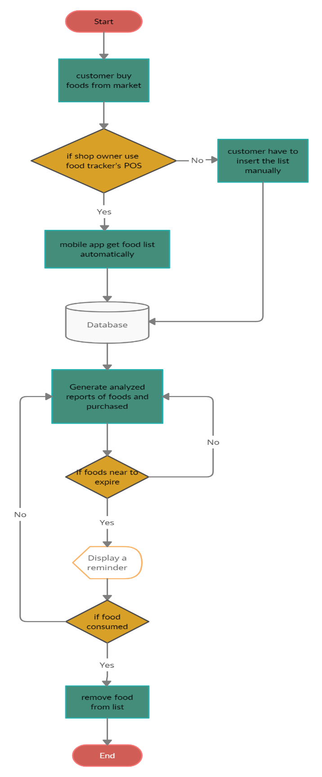

Figure 1. Food tracker Flowchart

# Task undertaken and outcomes

|  |  |  |  |
| --- | --- | --- | --- |
| **Task ID** | **Task undertaken** | **outcomes** | **percentage** |
| 1 | Android mobile application with basic login and registration | Designed, not yet developed | 10% |
| 2 | OCR implementation on android application | Identified the API and libraries to build the OCR method. But, not designed or developed | 10% |
| 3 | Real time database connection of the android application & POS | Identified the fields and created the ER diagram for the solution | 5% |
| 4 | POS system with basic sales and inventory management functions | Not yet designed or developed (TODO) | 0% |
| 5 | OCR implementation for POS system | Not yet designed or developed (TODO) | 0% |
| 6 | Data syncing on both system | Not yet designed or developed (TODO) | 0% |
| 7 | Analysed reports for both application | Not yet designed or developed (TODO) | 0% |

Table 1. Task undertaken and outcomes

# Products produced and product quality

Until now there are only designed main design and the user interfaces of the food tracker mobile application. With further studies and instructions of the supervisor this interface may be change into the different format.

## 6.1 Login

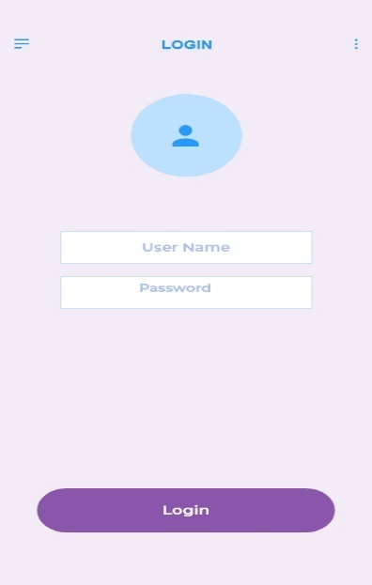

For this instance, this is the first interface user can see on their android mobile application. And it is better to add a Loading screen or the welcome screen to get the better user experience.

Other than that, sign in can be done in by entering the username and password which is customer created during the creating an account. Or else as another feature I can add feature to sign in using Google, Facebook likewise.

Figure 2. Login User Interface

## 6.2 Registration

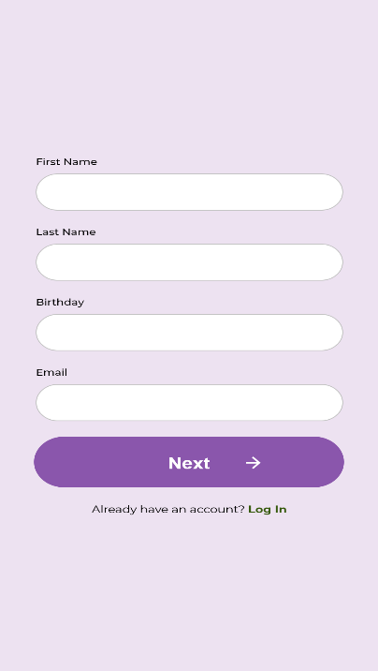

In the registration interface users can enter their personal details like first name, last name, birthday and email. For the better experience it has to add National identity card number, phone number and unique mode to identify and verify the customer.

Also, this interface having the feature to if the current user already has an account, they can simply redirect to login page.

Figure 3. Registration User Interface

## 6.3 Confirmation

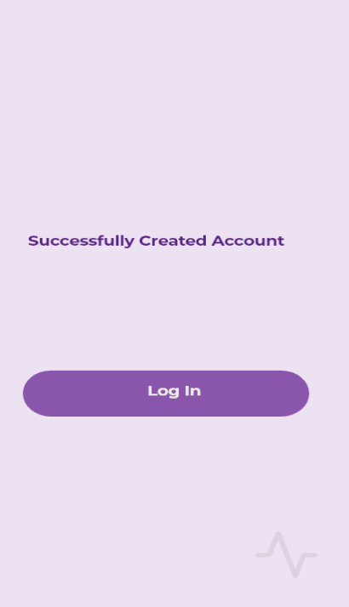

This confirmation page is created to acknowledge the user or customer that, they have created the account. So, it is a give the correct idea that, account has been created. For the future development it can be add some other features like authenticate the user using the email or the customer’s mobile number. It can be more authenticate other than using older methods to login

When customer or the application user get this message, they can move on to the login and can continue on the application

Figure 4. Confirmation User Interface

## 6.4 Main menu

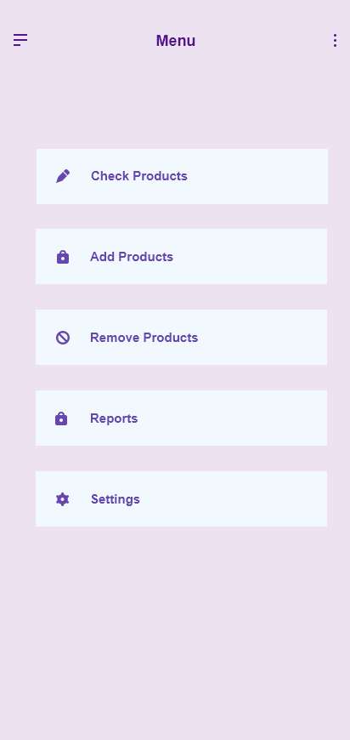

This is the main menu of the Food Tracker android application. It contains the all the features that the customer can use. On the top, it has “Check products” function. It will be used to checked purchased products and the product’s expire dates. In that function customer get and chance to update or edit data of their products. After that function there have a function called “Add Product”. Which is used to giving access to the user for add food items manually. It will using optical character recognition method to capture and automatically add to the list. Other than that, customers can enter the values manually.

Figure 5. Main Menu Interface

In the “Remove Product” function, customer get ability to remove the expired or consumed products from the list. So it has to be done manually or it can be change according to the other way. After that it has “Reports”. Which is showing the analysed reports of the purchased and consumed items likewise. “Setting” is the last function that available in the Food Tracker application. Form the setting users can customize their notification settings according to their preferences.

# Risks that have materialized and your responses, changes to the risk list

|  |  |  |
| --- | --- | --- |
| **ID** | **Risk** | **Response** |
| 1 | Used to develop POS system as a web system | I decided to change the language to Java because it will be safe and user friendly. |
| 2 | Analysed reports on both android and POS system | Have to refer some tutorial on creating the reports in both development environment |
| 3 | POS system’s OCR implementation | Have to use some 3rd party API |
| 4 | Time | Working with daily basis to reduce the pressure about this project |
| 5 | Unfamiliar codes | Refer tutorials on each code |
| 6 | Bugs/Issues | Refer online materials and fix them |

Table 2. Risk and Responses

# Schedule

## 7.1 Project Plan

|  |  |  |  |
| --- | --- | --- | --- |
| **ID** | **Stage** | **Deadline** | **Product/Deliverables/Outcome** |
| 1 | initiation | 11/17 | PID |
| 2 | Investigation and requirements | 12/03 | Analysis of existing business process.  Requirement document.  Evaluation of possible development technologies. |
| 3 | High level design | 12/07 | Design documents (Architecture, DB schema, modular decomposition, GUI style guide, etc) |
| 4 | Increment 1 | 01/22 | Sub-system providing customer facing functionality |
| 5 | Increment 2 | 02/10 | Sub-system providing communication between the internal function units |
| 6 | Increment 3 | 02/15 | POS system implementation |
| 7 | System and user acceptance testing | 03/01 | Final system/solution |
| 8 | Assemble and complete final report | 04/10 | PRCO303 Report |

Table 3. Project Schedule

# Resources

* **Android Studio** (version 2020.3)

As for this project solution, it is mainly targeted to use by the any of the customers, who brought foods. So, when commonly most people are using android operating system-based devices, I have to create this solution’s mobile application according to those people choice. Therefore, this mobile application will develop in Android. For that Android studio IDE is the better choice for the developing this mobile application. Not only that android studio having many different and unique features for the android application development. Which is including customizable android simulators, easy access for the different android libraries, etc.

* **Apache NetBeans**

For the development of the point of sales system for the shop owners, it is easy to use operating system independence language. Therefore, Java is the best and easy way to handle this situation. Other than that, there are lots of libraries are available for java language, which is very Important to create this project solution.

* **Adobe XD**

Adobe XD is giving better figure when creating the user interface and easy to understand the how the user experience when using this project. I have selected this software for when creating the user interface of the mobile application and the point of sales system.

* **Machine Learning kit on Android**

When developing the optical character recognition method for customers mobile application, I have to use this library to implement to that method.

# Learning undertaken and Required

* Android Machine Learning libraries

Google developer community have a better introduction to the beginner about the Machine Learning kits. This will be helpful for when implementing the optical character recognition method on android application

* Tesseract API

Which is machine learning library or the API that is use for character recognition. There are some courses and code explanation available in online.

* Firebase Database

Database system that used in android mobile application. Google developer community and YouTube have some valuable explanation of this technology.

# Appendices

## References

* Google Developers. 2022. *Text Recognition | ML Kit | Google Developers*. [online] Available at: <https://developers.google.com/ml-kit/vision/text-recognition> [Accessed 22 January 2022].
* GeeksforGeeks. 2022. *Tesseract OCR with Java with Examples - GeeksforGeeks*. [online] Available at: <https://www.geeksforgeeks.org/tesseract-ocr-with-java-with-examples/> [Accessed 22 January 2022].

## Proposal

**Food tracker**

**Proposer**

J. P. R. Chamuditha Jayaweera - 10707234

**Proposed supervisor**

Mr. Iman Ashly

**Problem statement**

One of main problem all around the world is food wastage. There are two main kind of food waste. Food loss and food waste. From that two categories food loss is a comparatively bigger than the food waste. Food loss can be defined as any edible food that goes uneaten at any stage. In addition to food’s that uneaten in homes and stores, or the in the fields, foods spoils in transportation and all other food that doesn’t make it to store.

When talk about the amount of food wastage only in America has about 68 percent or about 42.8 million tons of wasted food, generated in 2018 and it ended up landfills or combustion facilities. Moreover, food waste that is not handled properly or reclaimed properly through the composting can have many negative environment consequences. As an example, landfill gas from anaerobic digestion of organic matter is a major source of the greenhouse gas methane. And un-reclaimed phosphorus in food waste, leads further phosphate mining. Moreover, reducing food wastage in all a part of the food system is an important part of the reducing the environmental impact of agriculture, by reducing the total amount of water, land use and other resources.

However, for many people in the world food waste has become a habit. Buying more food than we need at markets, letting fruits and vegetables spoil at home or taking larger portions than we can eat. Sometimes we forgot what we bought and just leave in the refrigerator or in the pantry. And after the expiration date we dump those foods or products without consuming. If we are good enough to manage those, we can reduce wastages by ourselves. But with the busy lifestyle it is normal things forgot the products and foods stored in home. For that kind of instance, we can simply use a mobile application to get remind if our food going to expire.

**Project description**

As mentioned in the above most of the peoples living in these days are spending very busy lifestyle. They may be busy in the work as well as technology. Rather than the few years back, after the pandemic situation peoples are get closer to the new technology. They love to use new technology or new things other than the manual or old systems. So, for the food wastage we can simply use a mobile application. From that mobile application, user get notifications if their food that bought from the market are near to getting expire.

And not only that, but user can also see different kind of recipes from the food items that they have bought from market. And nowadays people are very much concerning about their foods. Even they limit foods to prevent from various diseases. So, from this application might help to choose wisely to select foods according to the calories. When user check out the application from mobile, he/she can see number of calories include in each food items. Another specialty of this mobile application is user does not need to spend time to add food items one by one to this application. This application will get all the data that user purchased from the market.

So, this is not only for the user, but this also connect with a shop. Normally supermarket have a specific database to store manufacture date, expire date, price, calorie amount of the product. When the customer or user buy the foods from that supermarket mobile application automatically get the details what he/she brought and save that information like wise. This project can save time, wastage, money, and the environment.

**Project keywords**

Foods, Tracking, Mobile, Application, healthy

**Requirements**

* APIs for the food identifications
* Hosting servers

**Finance**

Not available

**External organizations**

Not available

**Other staff**

Not available

## PID

* 1. **Introduction**

**1.1 About Us**

Food wastage is a very huge problem, and it is not just only in a one country, it is affected all around the world. There are two main types of food waste as food loss and food waste. Food loss can define as any food that is discarded, incinerated, or otherwise disposed of along the food supply chain from harvest but excluding the retail level and is not used for any other productive use, such as animal feed or seed. Food waste can be referred as food that discarded at the level of retailers, food service and providers and consumers. As a general food consumer, we can’t help to stop food loss, but we can help to stop to food wastage. We can use day to day technology devices for stop this wastage.

**1.2 Introduction**

Food is thing that if one can get and other cannot afford it. Some can get more food and other can’t have much. Most of the peoples are busy these days. They are not much care about the things other than themselves. So, people have forgot that little things that can be a huge problem as an example we can take food waste. Which can define as foods that discarded by the consumers. If we simply go through that we can refer food waste as, the foods or foods product that buy from market and discard or throw away without consume. That is not much big problem for the one single human, but it will be uncontrollable environmental matter which cause by the environment pollution. How can be that environment pollutions occur? It is caused by food wastages that we throw away fills with greenhouse gas also known as methene. And un-reclaimed phosphorus in the food leads further mining. This food waste can also be a reason for environmental effect on agriculture, by reducing the total amount of water, land, and other resources.

In the other hand food is basic need of a life. But there are countries which are suffer from the famine. One country’s people waste foods and some other country’s peoples are dying for not having enough foods for consumption. one in nine people do not have enough food to take, that’s 793 million people who are undernourished. if we manage it correctly, we can fair to all the people living around the world. When we are talking about the food wastage in numbers one third of all food produced is lost or wasted. Around 1.3 billion tonnes of food, costing the global economy close to $940 billion each year. The 10% of the greenhouse gases are come from the foods that is produced, but not eaten. If food waste was a country, it would be the third biggest greenhouse gas emitter after the United State of America and China. In those greenhouse gases which mainly contain methane, are 28x stronger than carbon dioxide.

As mentioned above we can help to protect our environment that cause a huge global problem by following simple rules. In the last two years’ time people are changed with pandemic situation and move on with new technologies. So how can be this revolution can change the food wastage. Most people are busy with their day-to-day life activities, work or education, family, or various activities. but the people never refuse to go through their mobile phones, laptop or any smart devices. Even they have a very busy lifestyle they spend at least small amount of time with their mobiles. Some people used smart devices just for browsing social media or internet and some of them are used to do their daily work. So, without wasting a time on social media how we can referral people to save the earth. We could get the biggest chance having the pandemic, which is now the people love to be using the technology other than the manual or old systems or methods.

Nowadays most of the shops/supermarkets are introduced their own brand mobile applications. Or they are selling products through the online food ordering companies and online web sites. So, there are lots or customers are using these facilities through their smart devices. and for those people can use mobile application which remainder if the customer’s bought foods are going to expire. And, by without wasting those foods, can use as an ingredient to make different foods. In these days, people are more care about foods calories and the energy amount contained in the foods. So, from this application user or customer will be able to get information of the calorie in their foods. They can get different food recipe according to the foods, that they owned according to the energy’s foods have. When these mobile application users are raising the amount of foods, that can be save without waste also raise. Personally, mobile application can be an advantage in many ways. It can help user’s health, financial, and creativity. From this mobile application can focus the users to make different kinds of food according to the different recipes. It can help to enhance the user’s creativity. Otherwise, when we manage our foods without wasting and get maximum use of foods it saves the money.

* 1. **Business Case**

**2.1 Business Need**

In these days, people are busier with different matters. They do not have much care about the food they bought from the supermarket or shops or their expire dates. But people are more familiar with mobile phones rather than the few years ago. So, from the mobile application user get notifications whenever the foods getting near to expire. Not only notification but also user can view different types of recipes from the foods that are going to expire and the foods which are bought and stored. And in this mobile application shows the number of calories that certain food has. by that, user can get clear picture for the foods that he should get or the foods that he should change.

**2.1.1 Underlaying Problem**

The expire date of each food are different, and users can not spend their time to create the list of foods that he/she bought on market.

**2.2 Business Objectives**

To save the foods without wasting and bring new recipes from foods customer have and

* Reduced the amount of money that waste from food waste.
* Remind the users if the foods that are not consumed, are going to expire
* Acknowledge the users how much calories they consumption.
* To bring healthier food recipes.
* Manage the foods items accordingly.

**3. Project Objectives**

1. To analyze the foods or the products which are wasting with weather conditions.

1. To analyze and figure it out how the shops/supermarkets databases save the information’s of the products.
2. To analyze potential development technologies and deployment solutions
3. To implement the new mobile application and POS software for the shops or supermarket.
4. To provide real-time mobile application and POS for the customers and the shop owners with a correct data.

**Chapter 4: Initial Scope**

1. Business processes (and their shortcomings) will be identified by observation, and (possibly) documented using UML activity diagrams.
2. The proposed system will allow
   1. Shop owners to release their bill as an electronic generated bill.
   2. Customers to view on purchased list on the mobile application.
   3. Customers will get food item list automatically after shop owners confirm.
   4. Customer can add manually if he/she bought foods or products from the shops which is not using this system POS software.
   5. Customers to get notifications or remainder about food or product expiration.
   6. Customers able to see recipe according to the foods he/she has bought.
   7. Generate recipe with the foods before if the one or more items are going to expire.
   8. Customers to remove products.
3. User requirements will be elicited using interviews, observation, and the development of user stories. User requirements will be expressed primarily in text.
4. The more complex user requirements will be elaborated into detailed system requirements either using text, use case descriptions and/or a use case realization. A class diagram will be produced.
5. **Method of Approach**

Software development will employ an incremental approach, with several increments focussing upon

1. Shop owners POS (Point of sales) system which maintain product details like expire date, manufacture date, and amount of energy or calories.
2. Customers mobile application that contains the main functions in the described project.
3. Interconnection between POS and mobile application with real-time and without data failure.
4. High quality user interface and user experience should include into both POS and mobile application.

Possible technologies are PHP/JavaScript/CSS/MySQL for the POS system and Android/Firebase for the mobile application, for hosting purpose have to use third party hosting sites. although a full evaluation will take place during the project.

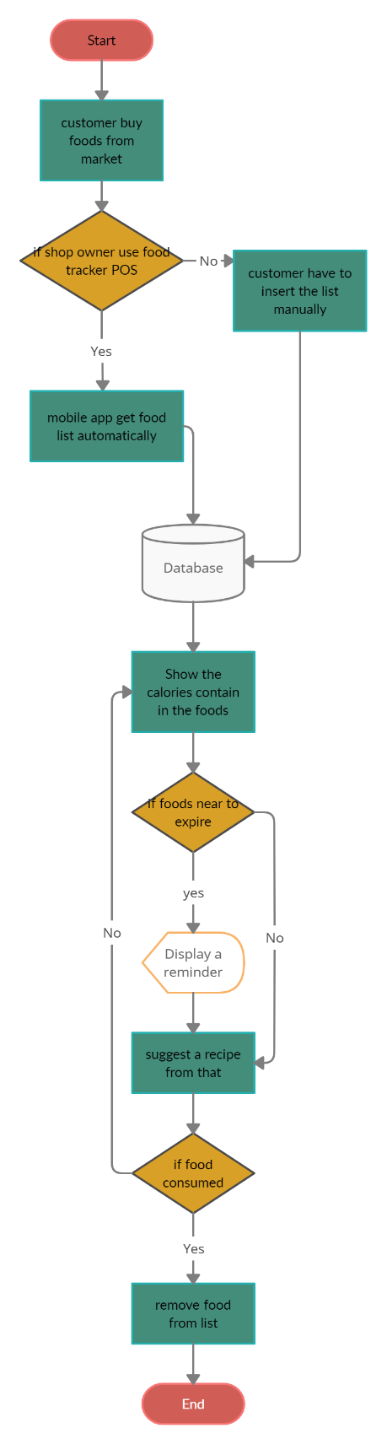

Figure 1. Flow chart for the **Food Tracker**

1. **Project Plan**

**6.1 Control Plan**

First have start with project proposal and then need to analyse and should create Project Initialisation Document (PID). Then must meet supervisor weekly and module leaders to get advice if there should be having to get change the project scope. With those of advice have to keep the logbook or diary for the changes that done to proposed system. Have to create documentation and video captures of the projects in every milestone. In other hand have to take risk and deploy the proposed system. Also, should create documentations which is mentioned in the module guide. Finally, must create final report for the created program and finalize the final software product.

**6.2 Communication plan**

In addition to ad-hoc supervisor meetings as necessary, planned review/feedback meetings will be held at the end of each stage in order to discuss the end-Stage report, the next Stage plan, and to review any technical deliverables produced during the stage. Feedback meetings will also be held following the submission of the two Interim reports. Any additional communication ( via email or additional meetings) will occur as needed.

Table 1. Stage 1 Plan

Table 2. Stage 2 Plan

1. **Initial Risk List**

What can go wrong and what management strategies are you adopting now to deal with these.

Table 3. Initial Risk List

1. **Initial Quality Plan**

What quality checks are you going to apply to your products, and when?

Table 4. Quality Plan



School of Computing and Mathematics

PRCO303

Final Stage Computing Project

INTERIM Report 2

BSc (Hons) Software Engineering

J. P. R. Chamuditha Jayaweera

Food Tracker

Supervisor: Mr. Iman Ashley

2020/2021

Table of Contents

1. Introduction 3

2. Business Case 4

2.1 Business Need 4

2.2 Business Objectives 4

3. Project Objectives 5

4. High-level diagram 9

5. Task undertaken and outcomes 13

6. Products produced and product quality 14

6.1 Login 14

6.2 User Signup 14

6.3 Forgot Password 15

6.4 Main menu 15

6.5 Add Items 16

6.5.1 OCR Method 16

6.5.2 Manual Method 18

6.6 View Items 18

6.7 Edit item 19

7. Test Case 20

7.1 Data Insertion using OCR in mobile application 20

8. Risks that have materialized and your responses, changes to the risk list 21

9. Schedule 22

9.1 Project Plan 22

10. Resources 23

11. Learning undertaken and Required 24

Appendices 25

References 25

Proposal 25

PID 28

Meeting minutes 35

# Introduction

Food is thing that if one can get and other cannot afford it. Some can get more food and other can’t have much. Most of the peoples are busy these days. They are not much care about the things other than themselves. So, people have forgot that little things that can be a huge problem as an example we can take food waste. Which can define as foods that discarded by the consumers. If we simply go through that we can refer food waste as, the foods or foods product that buy from market and discard or throw away without consume. That is not much big problem for the one single human, but it will be uncontrollable environmental matter which cause by the environment pollution. How can be that environment pollutions occur? It is caused by food wastages that we throw away fills with greenhouse gas also known as methene. And un-reclaimed phosphorus in the food leads further mining. This food waste can also be a reason for environmental effect on agriculture, by reducing the total amount of water, land, and other resources.

In the other hand food is basic need of a life. But there are countries which are suffer from the famine. One country’s people waste foods and some other country’s peoples are dying for not having enough foods for consumption. one in nine people do not have enough food to take, that’s 793 million people who are undernourished. if we manage it correctly, we can fair to all the people living around the world. When we are talking about the food wastage in numbers one third of all food produced is lost or wasted. Around 1.3 billion tonnes of food, costing the global economy close to $940 billion each year. The 10% of the greenhouse gases are come from the foods that is produced, but not eaten. If food waste was a country, it would be the third biggest greenhouse gas emitter after the United State of America and China. In those greenhouse gases which mainly contain methane, are 28x stronger than carbon dioxide.

As mentioned above we can help to protect our environment that cause a huge global problem by following simple rules. In the last two years’ time people are changed with pandemic situation and move on with new technologies. So how can be this revolution can change the food wastage. Most people are busy with their day-to-day life activities, work or education, family, or various activities. but the people never refuse to go through their mobile phones, laptop or any smart devices. Even they have a very busy lifestyle they spend at least small amount of time with their mobiles. Some people used smart devices just for browsing social media or internet and some of them are used to do their daily work. So, without wasting a time on social media how we can referral people to save the earth. We could get the biggest chance having the pandemic, which is now the people love to be using the technology other than the manual or old systems or methods.

Nowadays most of the shops/supermarkets are introduced their own brand mobile applications. Or they are selling products through the online food ordering companies and online web sites. So, there are lots or customers are using these facilities through their smart devices. and for those people can use mobile application which remainder if the customer’s bought foods are going to expire. And, by without wasting those foods, can use as an ingredient to make different foods. In these days, people are more care about foods calories and the energy amount contained in the foods. So, from this application user or customer will be able to get information of the calorie in their foods. They can get different food recipe according to the foods, that they owned according to the energy’s foods have. When these mobile application users are raising the amount of foods, that can be save without waste also raise. Personally, mobile application can be an advantage in many ways. It can help user’s health, financial, and creativity. From this mobile application can focus the users to make different kinds of food according to the different recipes. It can help to enhance the user’s creativity. Otherwise, when we manage our foods without wasting and get maximum use of foods it saves the money.

As a summary Food tracker is an application for most of the people who are struggling to manage the foods. It not only the mobile application for food management. It can analyse and suggest food items to users. And users can get a report of their consumption and wastages, based on their purchased food items. This project contains a system for the shopping markets. Its basically having the loyalty system, which they can track their customers purchased items. This solution will be a better answer for the huge amount of food wastage and environment pollution.

# Business Case

## 2.1 Business Need

In these days, people are busier with different matters. People does not pay special attention to their foods. And they do not have much care about the food they bought from the supermarket or shops or specially their expire dates. Nowadays people used eats junk foods or instant foods. Other than that, foods some are used to be healthy. So, they are only consuming healthy food products. But use of that healthy products they have to pay attention on their quality. So, when talk about the food quality, it is dependent on the foods expire date. But with this restless busy lifestyle they cannot give separate attention for that kind of information. Therefore, if the food products are expired, they cannot consumption. we can take it as a food wastage.

Fact, people are more familiar with mobile phones rather than the few years ago. By taking that as an advantage we can use mobile devices to give an update to the people about their foods.

So, from the mobile application user get notifications whenever the foods getting near to expire. Not only notification but also user can view different types of reports that analysed from the food item purchases from the stores. So, with these features we can save certain amounts of foods and money from wasting.

## 2.2 Business Objectives

As business objectives there are few main points to consider when developing this solution. Basically, this project is based on the “How to reduce food wastage”. It is huge problem rise all around the global. Food wastage can mainly affect the environment pollution and can be threatened to the many living species including the humans. So other than that matter, there are hundreds of thousands, or millions of people are dying because of the hunger and malnutrition. This solution can take as a first step to avoid this crisis by managing foods correctly in our own home. For archive this milestone, we can name some of our business objectives as below,

* To save the foods without wasting and give better understanding about food wastage.
* Reduced the amount of money that waste from food waste.
* Remind the users if the foods that are not consumed, are going to expire.
* Acknowledge the users how much spent on their food items.
* Manage the foods items accordingly.

# Project Objectives

On this project there are few main project objectives should have to consider. Other than that, this project is about a solution for food wastage. Then we have to consider what must be done for the archive main objective of this project. Below are some main objective points, will have to consider when developing this solution.

1. To analyze the foods or the products which are wasting with weather conditions.

When considering food wastage, all the food products wastage are not same. They are different in different reason, such as dried foods or the grains are last longer than the vegetables or fruits. And when talk about food packing, people cannot store some foods in refrigerator. Or otherwise, cannot store in a direct sunlight. That will directly affect the food product quality. So, it can have shorter time period to expire than the expected. Which means there may be an unexpected change due to the natural causes. As a good productive project solution, it has to analyze what type of foods that can be waste without knowing the user. When we take an example, Fruits are ripe quickly normally the customers are may consumed it, but if the customer does not consume and keep it refrigerator it may can keep fresh for several days, but if the customer does not keep that same item in refrigerator, it may be turn into food waste. So, in that case when developing the solution need to find out which product can be waste more quickly with various environmental conditions. As an example, when customer brought an apple from the market and if he/she decide to store in refrigerator it will keep fresh or keep it without wasting it for several days other than the leave it in outside.

As a project objective I have to identify what are the solution when customers add these kind of food products to their product list. It is an uncontrollable issue that have to face when developing this project. Because from this solution cannot control how the user’s store food item in their place. Therefore, this type of issues I have go through the all the kinds of food items that will affect environment factors and give an average time period for each of the food item.

1. To analyze and figure it out how the shops/supermarkets databases save the information’s of the products.

In the large-scale supermarket, they are having a huge range of products in different categories. Also, they maintain loyalty membership which track their customers purchases and used analyze their sales. When we take an example in the fruit category their may be apple and that can be categorize into different types. And for each type they valued different prices. Likewise, there may be complex and unique database system owned by large supermarket or shops. When we take a single grocery store, they may only have the basic point of sales system. For that kind of issue, we have to install this project solution’s point of sales system to maintain loyalty customers database. Or otherwise, customers can use their mobile device and add each product by themselves. And those stored data have to use for the analyzing. Those analyzed data can be used for both customers and the shop owners. So the solution database should be created to help the analyzing part as well.

As a summery, in this solution also have to figure it out how they manage to store data in efficient way and what are the areas they area collecting the data about. Because if we take on food category, there might be hundreds of types of foods in a single category. So, it has to be done in very efficient way. For this solution, it has to find out the expire date of each product. But it can be different with same type of food items. So how could be save data or used data to represent.

1. To analyze potential development technologies and deployment solutions.

For this solution there are mainly two types of target users, and they are having different operating systems. One types of users are the customers. Which is basically type of audience this solution is targeting for. And other hand this project is supporting the shop owners. When we talk about the customers or the main group of target audience, we can assume most of the people are using android operating system based mobile device. So, getting that as an advantage I can develop this solution for the android operating system-based devices. And for the database connectivity of the mobile application can made up with a firebase database. It is the fast and easiest way to connect mobile application with the mobile database. Other than that, this solution mobile application uses an Optical Character Recognition system. For that, customers can already use their mobile’s camera. In the back end I have to use several libraries for that.

On the other hand, shop owners generally using a Microsoft windows operating system-based computer or else some shop owners can use a Linux operating system-based computer. So that situation it is better to use a programming language that operating system independence. Java is the best solution for that kind of situation. And java will be more advantage to here because of the customer’s mobile application. In this point of sales system also have an Optical Character Recognition system for identify the product details such as product id, product expire date, manufacture date, or that kind of important data. Other than the optical character recognition method, it has basic functions of point of sales system. Such as transaction, which used generate sales receipt, and then it has inventory management ability for adding, updating or else removing the products from the database. When talk about the database whole system database has to store in separate server. There are different reasons for that. Mainly reason for that can be describe as the database’s protection. If the data are stored in the shop and there is a environmental cause disaster like fire or earthquake or the human cause disasters like robbery or data breach can damage or destroy valuable data. And the second reason to host database in separate server is, this project is syncing with shop owners and customers details. For example, one customer may be a loyalty member of several shops, but he still has to get products details from those shops. Because of that data cannot be saved in local database. It should be definitely host in a server.

1. To implement the new mobile application for customers and POS software for the shops or supermarket.

In this solution, there are two main parts for the project. One application for the shop owners to manage or keep track on the customers and for manage the sales. Which can describe as Point of sales. And the other product of this solution is mobile application for customers. Which helps to manage their foods. In shop owner’s application it should store food items data, customers data and it should manage to identify the expire dates of the products by Optical Character Recognition (OCR). All these should be done under less amount of time. It should be not wasting customers of shop owners or cashier’s valuable time. As summery of this solution’s point of sales system is it can do the transactions which are done by the customers, keeping the purchased records of each loyalty customers, identify and save the data like price, expire date, manufacturing data by using Optical Character Recognition system implemented, transfer saved data into the loyalty customers mobile application right after the purchased, generate analyzed sales reports according to the records the customers purchased.

Other than that, on customer’s mobile application should generate analyzed report for the each of purchased or according to the certain time period. Then he/she can identify different areas that should concern about. As an example, customers can get better idea what they bought most in the certain time and what are the food items that waste more in a certain time period. Other than that, analyzed reports should identify the regularly consumptions and notify the users, if they are not having in the customers or the user’s food list. Then he can get acknowledge and buy those products. Not only the analyzed report but also in the customers mobile application they can add food products or different items by themselves manually. Which means if customers buy some foods items from the store that does not using this project solution’s point of sales system, still customer can add manually those bought products. For that mobile application should also have a method to add it manually. Therefore, it can used Optical Character Reading method, which give user’s an easy method add to product list. And customers can add items manually entering values. Then customers or users can change the product details or delete item. Not only those features, but the main feature of this solution is also when the customer buy items from the store or supermarket that having the project solution’s point of sales system, after the purchase those products are automatically adding to the customers products list. So, customers never have to spent time on adding items to his product list. Another feature of this solution’s mobile application is the notifications. Those notifications will pop-up with according to the expiration of each product. It will notify if the item is near to getting expire. For the greater user experience, there will be setting section that user can change notifications preference according to their willing. There will be like how it should show as a message and notification sound. By personalize those settings, customers or users can easy and get greater experience from this mobile application.

1. To provide real-time mobile application and POS for the customers and the shop owners with a correct data.

This food tracker application is design to retrieve purchased data from the shop owners point of sales system. By that user does not want to add manually to their item list on the mobile device. For that instance, I have to use database that work as a real-time. as a solution I choose firebase database which is simple to use and can get quick responses after the database update. Real time is a major point for this application. Because right after the customers purchases, it has to be added into the personal item list with the products expire date. Other than that firebase is a most suitable database system for the android devices. By this point customer will get better real-time mobile application experience.

Other than the food tracker mobile application, there is point of sales system for the shop owners also. For that type of application, it should be better to use a normalized database. Because there are many types of products to handle. And need fast response and reliable. So, SQL related database can be best for this type of situation.

# High-level diagram



Figure 1. Food tracker Flowchart

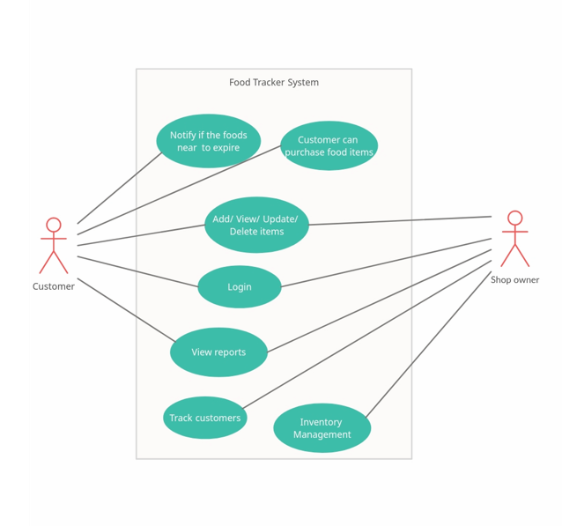

Food Tracker System UML use case Diagram

Figure 2. Food Tracker's use case diagram

Food Tracker Database Diagram

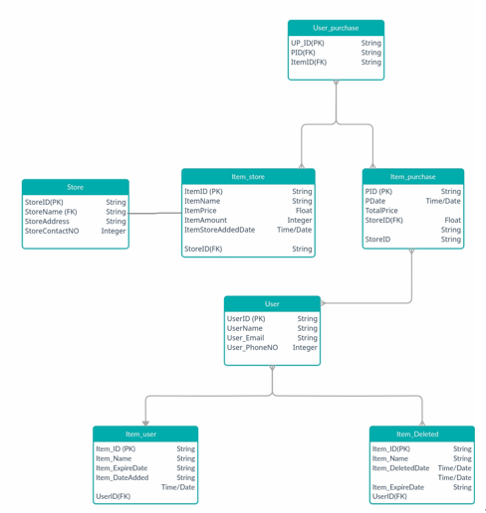

Figure 3. Food Tracker's Database Diagram

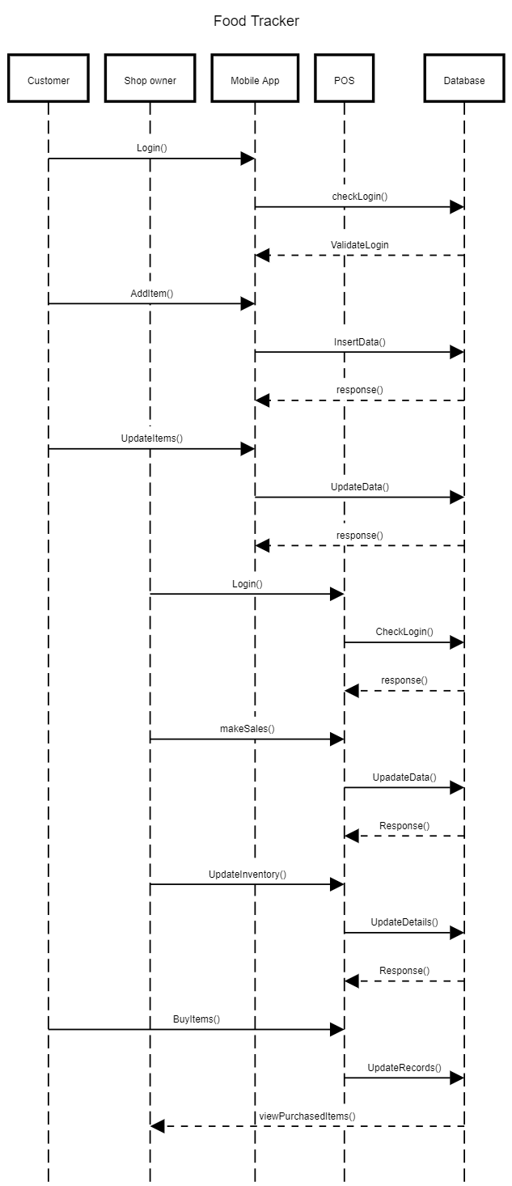

Figure 4. Food Tracker's Sequence Diagram

# Task undertaken and outcomes

|  |  |  |  |
| --- | --- | --- | --- |
| **Task ID** | **Task undertaken** | **outcomes** | **percentage** |
| 1 | Android mobile application with basic login and registration | Completed | 100% |
| 2 | OCR implementation on android application | Completed and fully functioning. but must add more features with User experience. | 80% |
| 3 | Manual Data insertion and data edit for the mobile application | Completed | 100% |
| 4 | Real time database connection of the android application & POS | Firebase database used in the Android app and POS | 60% |
| 5 | POS system with basic sales and inventory management functions | Developed some User Interfaces, but not fully functioning | 30% |
| 6 | OCR implementation for POS system | Identified the API’s and Dataset, not implemented yet. | 20% |
| 7 | Data syncing on both system | Android data syncing correctly. | 50% |
| 8 | Analysed reports for both application | Not yet designed or developed (TODO) | 0% |

Table 1. Task undertaken and outcomes

# Products produced and product quality

In here let’s discuss the implementation between the start of the project which included in the interim 1 document and implementation have done so far. Since the last report mobile application now having full functioning methods. Which including user login with user email and password, login using with user’s google account, users can use their Facebook credentials for the mobile application login. Other than that mobile application main function, the OCR technology is now working properly. Which the user can capture the item’s details including name and expire date.

## 6.1 Login

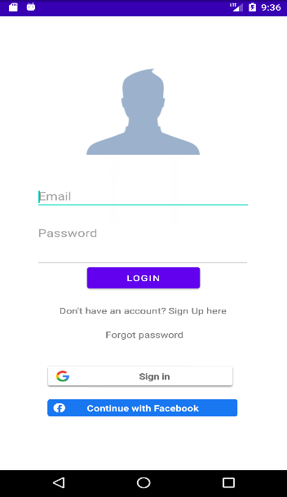

Previously (in interim 1) the login of the mobile has not implemented. Only had designed the user interface in the Adobe XD. In that design also only having the basic user login, which not including various options to mobile application user to choose.

When to login to this application user can choose several options. Such as they can create their own account, they can use their own Gmail address or else they can login to application using users Facebook. And once the user login to the application they do not need to a login every time when opening the application.

Figure 5. Login User Interface

## 6.2 User Signup

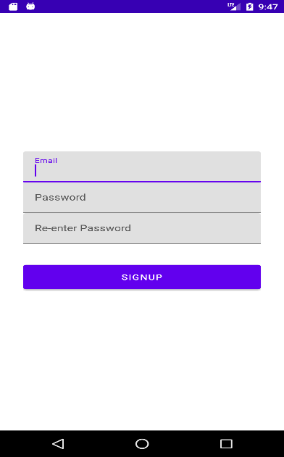

In the Signup users only have to enter their valid email and password. For the extra validation, users have to re-enter their password to confirm password is memorisable.

After creating the account users does not need to login again to the account.it automatically login and redirect to home page of the application

Figure 6. Registration User Interface

## 6.3 Forgot Password

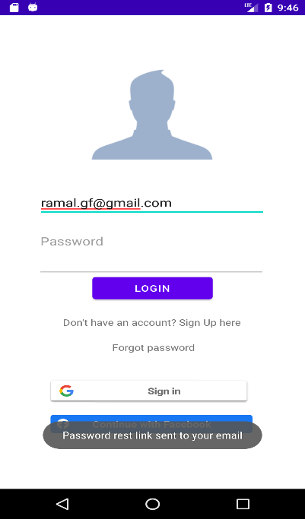

For the users who does not remember their password of their created account; users can simply enter their email address and tap the “**Forgot password**” option. When user done that their will be email will send to user email address to reset their account’s password. Which the user can reset password, without wasting time and could done in veery easy steps.

After the password is reset, user have to login to the application again. But still user can access their previous account records.

Figure 7. Forgot Password

## 6.4 Main menu

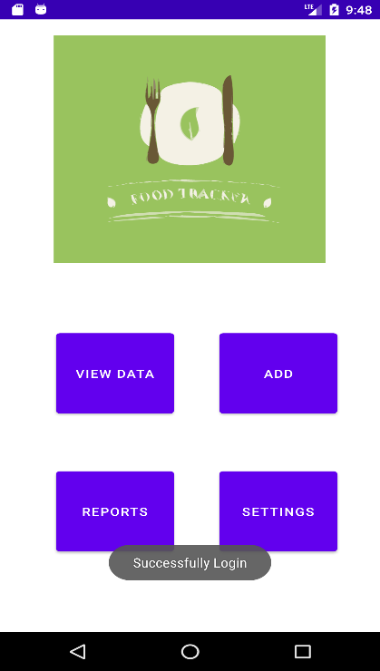

This is the main menu of the Food Tracker android application. It contains the all the features that the customer can use. On the top, it has “Check products” function. It will be used to checked purchased products and the product’s expire dates. In that function customer get and chance to update or edit data of their products. After that function there have a function called “Add Product”. Which is used to giving access to the user for add food items manually. It will using optical character recognition method to capture and automatically add to the list. Other than that, customers can enter the values manually.

In the “Remove Product” function, customer get ability to remove the expired or consumed products from the list. So, it has to be done manually or it can be change according to the other way. After that it has “Reports”. Which is showing the analysed reports of the purchased and consumed items likewise. “Setting” is the last function that available in the Food Tracker application. Form the setting users can customize their notification settings according to their preferences.

Figure 8. Main Menu Interface after the login to application

## 6.5 Add Items

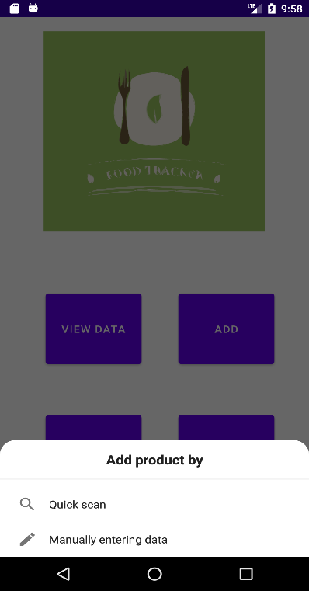

Figure 9. Add item pop-up message

Users can add their food items which are bought from the shops in this add data function. It is basically divided into 2 parts which can be define as Manual data insertion and Optical Character Recognition method. So, if the user selects the add data button it will popup a confirmation message that asking the ways of adding data. In that message user can select either OCR method or the manually adding method.

### OCR Method

Once the user selects the OCR methods to insert items data, they can add items by using their mobile device camera and capture the items name and item’s expire date respectively. It will automatically capture the and analyse the data and with the user’s confirmation it will be added to the mobile application database.

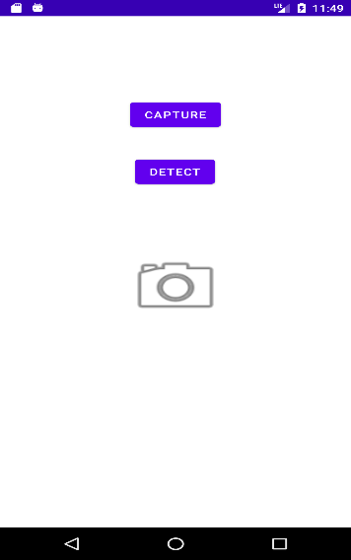

For the now instance it only having very simple user interface. And also, it can only identify the expire date and still not combined with main add item functions.

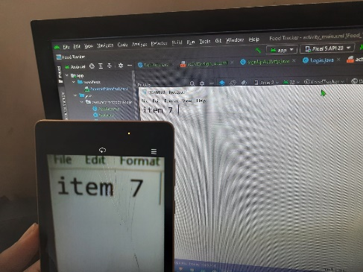

Figure 10. OCR main user interface

Figure 11. Capturing the data from the camera

For the example here I get the real scenario of getting capture for the OCR. And it is not capturing the handwriting, because of that user willing to add the item form OCR should not be written in the list. And here I still develop for the capture one picture and analyse, it can be hard to used for the users. So in the further development it can be a live recording the item list. For simple explanation it is will be like user have to open the camera and focus on to item name or item barcode to capture item name and user have to focus the camera to item expire date section. Then it will automatically capture those relevant data.

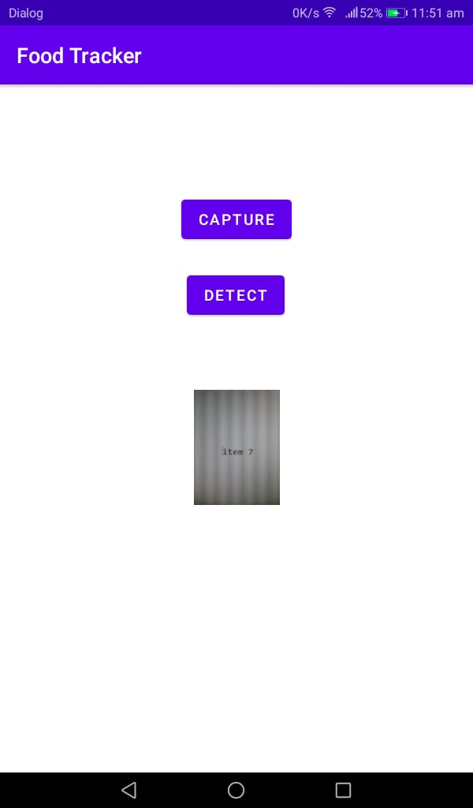

Other wise in this moment users have to capture the item name and expire date respectively. If it further breakdown first of all user have to click capture button and capture the item name or the item expired date. Then the user can see what is picture they have been captured.

Figure 12. confirming captured image

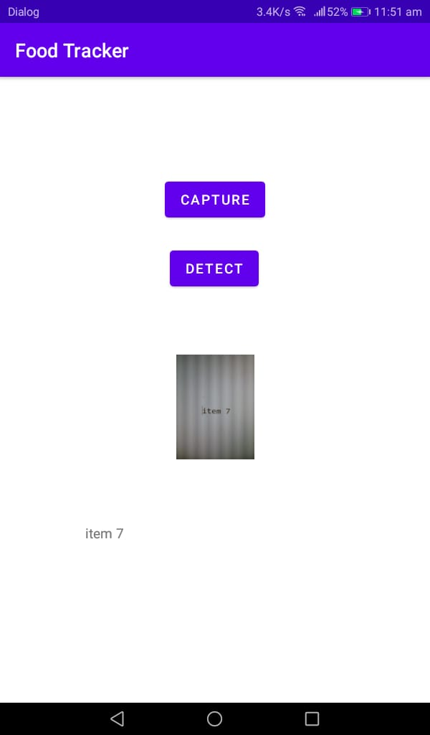

After user confirm the picture that they have been inserted is correct, they need to tap or click the “DETECT” button. Once they click that button OCR method will analyse and show the result of what the application has detect and analysed captured from the user entered image.

Figure 13. OCR result showing

### Manual Method

If the user selects manual method of data insertion from the main menu popup message, it will redirect to this interface. Which the users can insert their items data directly with keyboard input. User can simply add item name and its expired date. Once the data added, the items on his list will show down below

And if the user wants to edit the data that entered or captures, there is a button down the list called “Edit” under the list. It will redirect to the interface where the users can edit or delete their data.

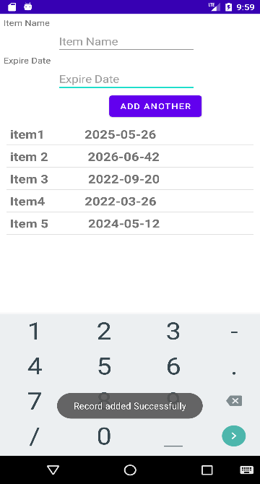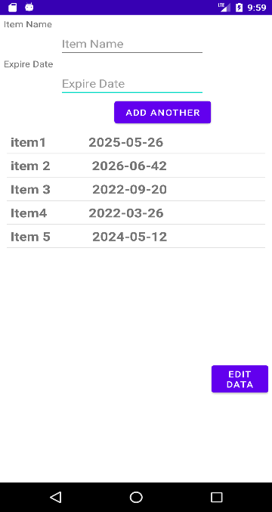

Figure 14. Add item confirmation messages

Figure 15. Add item user interface

## 6.6 View Items

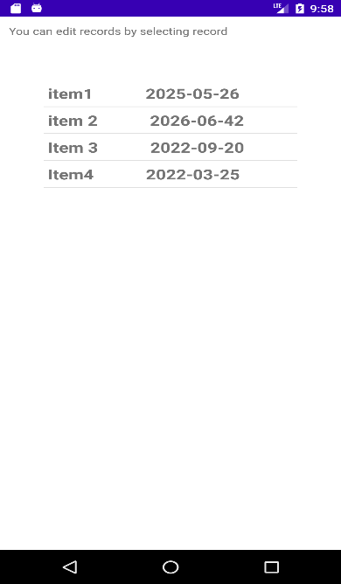

Figure 16. View Item user interface

In here it shows all the items and its expired date that currently on the items list.

If the user wants to change their data, can select the item that they want to update and it automatically shows in the interface that user can update their details in easy way.

## 6.7 Edit item

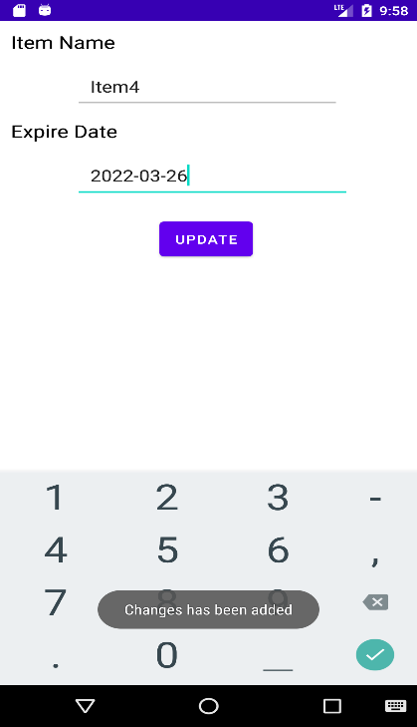

Once the user wants to edit items details, that request can fulfil in this user interface. For this instance, it only having update function. But with the further development delete item function will also add to this method.

# Test Case

## 7.1 Data Insertion using OCR in mobile application

|  |  |  |  |  |  |  |
| --- | --- | --- | --- | --- | --- | --- |
| **Test Case Name** | **Test case Step** | **Action** | **Test Data** | **Expected Result** | **Test Result** | **Note** |
| Test App | 1 | Open App | - | App Opened | App Opened | Success |
| Test App | 2 | Grant Permissions | - | Permission Granted | Permission Granted | Success |
| Test App | 3 | - | - | Camera Opened | Camera Opened | Success |

|  |  |  |  |  |  |  |
| --- | --- | --- | --- | --- | --- | --- |
| **Test Case Name** | **Test Case Step** | **Action** | **Test Data** | **Expected Result** | **Test Result** | **Note** |
| Test OCR | 1 | Hover over printed text | Item 7 | Item 7 | Item 7 | Success |
| Test OCR | 2 | Hover over written text | Item 7 | Item 7 | TTEM 7 | Fail |

# Risks that have materialized and your responses, changes to the risk list

|  |  |  |
| --- | --- | --- |
| **ID** | **Risk** | **Response** |
| 1 | Used to develop POS system as a web system | I decided to change the language to Java because it will be safe and user friendly. |
| 2 | Analysed reports on both android and POS system | Have to refer some tutorial on creating the reports in both development environment |
| 3 | POS system’s OCR implementation | Have to use some 3rd party API |
| 4 | Time | Working with daily basis to reduce the pressure about this project |
| 5 | Unfamiliar codes | Refer tutorials on each code |
| 6 | Bugs/Issues | Refer online materials and fix them |

Table 2. Risk and Responses

# Schedule

## 9.1 Project Plan

|  |  |  |  |
| --- | --- | --- | --- |
| **ID** | **Stage** | **Deadline** | **Product/Deliverables/Outcome** |
| 1 | initiation | 11/17 | PID |
| 2 | Investigation and requirements | 12/03 | Analysis of existing business process.  Requirement document.  Evaluation of possible development technologies. |
| 3 | High level design | 12/07 | Design documents (Architecture, DB schema, modular decomposition, GUI style guide, etc) |
| 4 | Increment 1 | 01/22 | Sub-system providing customer facing functionality |
| 5 | Increment 2 | 02/10 | Sub-system providing communication between the internal function units |
| 6 | Increment 3 | 02/15 | POS system implementation |
| 7 | System and user acceptance testing | 03/15 | Final system/solution |
| 8 | Assemble and complete final report | 04/10 | PRCO303 Report |

Table 3. Project Schedule

# Resources

* **Android Studio** (version 2020.3)

As for this project solution, it is mainly targeted to use by the any of the customers, who brought foods. So, when commonly most people are using android operating system-based devices, I have to create this solution’s mobile application according to those people choice. Therefore, this mobile application will develop in Android. For that Android studio IDE is the better choice for the developing this mobile application. Not only that android studio having many different and unique features for the android application development. Which is including customizable android simulators, easy access for the different android libraries, etc.

* **Apache NetBeans**

For the development of the point of sales system for the shop owners, it is easy to use operating system independence language. Therefore, Java is the best and easy way to handle this situation. Other than that, there are lots of libraries are available for java language, which is very Important to create this project solution.

* **Adobe XD**

Adobe XD is giving better figure when creating the user interface and easy to understand the how the user experience when using this project. I have selected this software for when creating the user interface of the mobile application and the point of sales system.

* **Machine Learning kit on Android**

When developing the optical character recognition method for customers mobile application, I have to use this library to implement to that method.

# Learning undertaken and Required

* Android Machine Learning libraries

Google developer community have a better introduction to the beginner about the Machine Learning kits. This will be helpful for when implementing the optical character recognition method on android application

* Tesseract API

Which is machine learning library or the API that is use for character recognition. There are some courses and code explanation available in online.

* Firebase Database

Database system that used in android mobile application. Google developer community and YouTube have some valuable explanation of this technology.

# Appendices

## References

* Google Developers. 2022. *Text Recognition | ML Kit | Google Developers*. [online] Available at: <https://developers.google.com/ml-kit/vision/text-recognition> [Accessed 22 January 2022].
* GeeksforGeeks. 2022. *Tesseract OCR with Java with Examples - GeeksforGeeks*. [online] Available at: <https://www.geeksforgeeks.org/tesseract-ocr-with-java-with-examples/> [Accessed 22 January 2022].

## Proposal

**Food tracker**

**Proposer**

J. P. R. Chamuditha Jayaweera - 10707234

**Proposed supervisor**

Mr. Iman Ashly

**Problem statement**

One of main problem all around the world is food wastage. There are two main kind of food waste. Food loss and food waste. From that two categories food loss is a comparatively bigger than the food waste. Food loss can be defined as any edible food that goes uneaten at any stage. In addition to food’s that uneaten in homes and stores, or the in the fields, foods spoils in transportation and all other food that doesn’t make it to store.

When talk about the amount of food wastage only in America has about 68 percent or about 42.8 million tons of wasted food, generated in 2018 and it ended up landfills or combustion facilities. Moreover, food waste that is not handled properly or reclaimed properly through the composting can have many negative environment consequences. As an example, landfill gas from anaerobic digestion of organic matter is a major source of the greenhouse gas methane. And un-reclaimed phosphorus in food waste, leads further phosphate mining. Moreover, reducing food wastage in all a part of the food system is an important part of the reducing the environmental impact of agriculture, by reducing the total amount of water, land use and other resources.

However, for many people in the world food waste has become a habit. Buying more food than we need at markets, letting fruits and vegetables spoil at home or taking larger portions than we can eat. Sometimes we forgot what we bought and just leave in the refrigerator or in the pantry. And after the expiration date we dump those foods or products without consuming. If we are good enough to manage those, we can reduce wastages by ourselves. But with the busy lifestyle it is normal things forgot the products and foods stored in home. For that kind of instance, we can simply use a mobile application to get remind if our food going to expire.

**Project description**

As mentioned in the above most of the peoples living in these days are spending very busy lifestyle. They may be busy in the work as well as technology. Rather than the few years back, after the pandemic situation peoples are get closer to the new technology. They love to use new technology or new things other than the manual or old systems. So, for the food wastage we can simply use a mobile application. From that mobile application, user get notifications if their food that bought from the market are near to getting expire.

And not only that, but user can also see different kind of recipes from the food items that they have bought from market. And nowadays people are very much concerning about their foods. Even they limit foods to prevent from various diseases. So, from this application might help to choose wisely to select foods according to the calories. When user check out the application from mobile, he/she can see number of calories include in each food items. Another specialty of this mobile application is user does not need to spend time to add food items one by one to this application. This application will get all the data that user purchased from the market.

So, this is not only for the user, but this also connect with a shop. Normally supermarket have a specific database to store manufacture date, expire date, price, calorie amount of the product. When the customer or user buy the foods from that supermarket mobile application automatically get the details what he/she brought and save that information like wise. This project can save time, wastage, money, and the environment.

**Project keywords**

Foods, Tracking, Mobile, Application, healthy

**Requirements**

* APIs for the food identifications
* Hosting servers

**Finance**

Not available

**External organizations**

Not available

**Other staff**

Not available

## PID

* 1. **Introduction**

**1.1 About Us**

Food wastage is a very huge problem, and it is not just only in a one country, it is affected all around the world. There are two main types of food waste as food loss and food waste. Food loss can define as any food that is discarded, incinerated, or otherwise disposed of along the food supply chain from harvest but excluding the retail level and is not used for any other productive use, such as animal feed or seed. Food waste can be referred as food that discarded at the level of retailers, food service and providers and consumers. As a general food consumer, we can’t help to stop food loss, but we can help to stop to food wastage. We can use day to day technology devices for stop this wastage.

**1.2 Introduction**

Food is thing that if one can get and other cannot afford it. Some can get more food and other can’t have much. Most of the peoples are busy these days. They are not much care about the things other than themselves. So, people have forgot that little things that can be a huge problem as an example we can take food waste. Which can define as foods that discarded by the consumers. If we simply go through that we can refer food waste as, the foods or foods product that buy from market and discard or throw away without consume. That is not much big problem for the one single human, but it will be uncontrollable environmental matter which cause by the environment pollution. How can be that environment pollutions occur? It is caused by food wastages that we throw away fills with greenhouse gas also known as methene. And un-reclaimed phosphorus in the food leads further mining. This food waste can also be a reason for environmental effect on agriculture, by reducing the total amount of water, land, and other resources.

In the other hand food is basic need of a life. But there are countries which are suffer from the famine. One country’s people waste foods and some other country’s peoples are dying for not having enough foods for consumption. one in nine people do not have enough food to take, that’s 793 million people who are undernourished. if we manage it correctly, we can fair to all the people living around the world. When we are talking about the food wastage in numbers one third of all food produced is lost or wasted. Around 1.3 billion tonnes of food, costing the global economy close to $940 billion each year. The 10% of the greenhouse gases are come from the foods that is produced, but not eaten. If food waste was a country, it would be the third biggest greenhouse gas emitter after the United State of America and China. In those greenhouse gases which mainly contain methane, are 28x stronger than carbon dioxide.

As mentioned above we can help to protect our environment that cause a huge global problem by following simple rules. In the last two years’ time people are changed with pandemic situation and move on with new technologies. So how can be this revolution can change the food wastage. Most people are busy with their day-to-day life activities, work or education, family, or various activities. but the people never refuse to go through their mobile phones, laptop or any smart devices. Even they have a very busy lifestyle they spend at least small amount of time with their mobiles. Some people used smart devices just for browsing social media or internet and some of them are used to do their daily work. So, without wasting a time on social media how we can referral people to save the earth. We could get the biggest chance having the pandemic, which is now the people love to be using the technology other than the manual or old systems or methods.

Nowadays most of the shops/supermarkets are introduced their own brand mobile applications. Or they are selling products through the online food ordering companies and online web sites. So, there are lots or customers are using these facilities through their smart devices. and for those people can use mobile application which remainder if the customer’s bought foods are going to expire. And, by without wasting those foods, can use as an ingredient to make different foods. In these days, people are more care about foods calories and the energy amount contained in the foods. So, from this application user or customer will be able to get information of the calorie in their foods. They can get different food recipe according to the foods, that they owned according to the energy’s foods have. When these mobile application users are raising the amount of foods, that can be save without waste also raise. Personally, mobile application can be an advantage in many ways. It can help user’s health, financial, and creativity. From this mobile application can focus the users to make different kinds of food according to the different recipes. It can help to enhance the user’s creativity. Otherwise, when we manage our foods without wasting and get maximum use of foods it saves the money.

* 1. **Business Case**

**2.1 Business Need**

In these days, people are busier with different matters. They do not have much care about the food they bought from the supermarket or shops or their expire dates. But people are more familiar with mobile phones rather than the few years ago. So, from the mobile application user get notifications whenever the foods getting near to expire. Not only notification but also user can view different types of recipes from the foods that are going to expire and the foods which are bought and stored. And in this mobile application shows the number of calories that certain food has. by that, user can get clear picture for the foods that he should get or the foods that he should change.

**2.1.1 Underlaying Problem**

The expire date of each food are different, and users can not spend their time to create the list of foods that he/she bought on market.

**2.2 Business Objectives**

To save the foods without wasting and bring new recipes from foods customer have and

* Reduced the amount of money that waste from food waste.
* Remind the users if the foods that are not consumed, are going to expire
* Acknowledge the users how much calories they consumption.
* To bring healthier food recipes.
* Manage the foods items accordingly.

**3. Project Objectives**

1. To analyze the foods or the products which are wasting with weather conditions.

1. To analyze and figure it out how the shops/supermarkets databases save the information’s of the products.
2. To analyze potential development technologies and deployment solutions
3. To implement the new mobile application and POS software for the shops or supermarket.
4. To provide real-time mobile application and POS for the customers and the shop owners with a correct data.

**Chapter 4: Initial Scope**

1. Business processes (and their shortcomings) will be identified by observation, and (possibly) documented using UML activity diagrams.
2. The proposed system will allow
   1. Shop owners to release their bill as an electronic generated bill.
   2. Customers to view on purchased list on the mobile application.
   3. Customers will get food item list automatically after shop owners confirm.
   4. Customer can add manually if he/she bought foods or products from the shops which is not using this system POS software.
   5. Customers to get notifications or remainder about food or product expiration.
   6. Customers able to see recipe according to the foods he/she has bought.
   7. Generate recipe with the foods before if the one or more items are going to expire.
   8. Customers to remove products.
3. User requirements will be elicited using interviews, observation, and the development of user stories. User requirements will be expressed primarily in text.
4. The more complex user requirements will be elaborated into detailed system requirements either using text, use case descriptions and/or a use case realization. A class diagram will be produced.
5. **Method of Approach**

Software development will employ an incremental approach, with several increments focussing upon

1. Shop owners POS (Point of sales) system which maintain product details like expire date, manufacture date, and amount of energy or calories.
2. Customers mobile application that contains the main functions in the described project.
3. Interconnection between POS and mobile application with real-time and without data failure.
4. High quality user interface and user experience should include into both POS and mobile application.

Possible technologies are PHP/JavaScript/CSS/MySQL for the POS system and Android/Firebase for the mobile application, for hosting purpose have to use third party hosting sites. although a full evaluation will take place during the project.



Figure 1. Flow chart for the **Food Tracker**

1. **Project Plan**

**6.1 Control Plan**

First have start with project proposal and then need to analyse and should create Project Initialisation Document (PID). Then must meet supervisor weekly and module leaders to get advice if there should be having to get change the project scope. With those of advice have to keep the logbook or diary for the changes that done to proposed system. Have to create documentation and video captures of the projects in every milestone. In other hand have to take risk and deploy the proposed system. Also, should create documentations which is mentioned in the module guide. Finally, must create final report for the created program and finalize the final software product.

**6.2 Communication plan**

In addition to ad-hoc supervisor meetings as necessary, planned review/feedback meetings will be held at the end of each stage in order to discuss the end-Stage report, the next Stage plan, and to review any technical deliverables produced during the stage. Feedback meetings will also be held following the submission of the two Interim reports. Any additional communication ( via email or additional meetings) will occur as needed.

Table 1. Stage 1 Plan

Table 2. Stage 2 Plan

1. **Initial Risk List**

What can go wrong and what management strategies are you adopting now to deal with these.

Table 3. Initial Risk List

1. **Initial Quality Plan**

What quality checks are you going to apply to your products, and when?

Table 4. Quality Plan

## Meeting minutes

